# COPYRIGHT

The author has agreed that the library, Department of Geomatics Engineering, Pashchimanchal Campus, Institute of Engineering may make this project report freely available for inspection. Moreover, the author has agreed that permission for extensive copying of this project report for scholarly purpose may be granted by professor(s) who supervised the work recorded here in or, in their absence, by the Head of the Department wherein, the project was done. It is understood that the recognition will be given to the authors of this project report and to the Department of Geomatics Engineering, Pashchimanchal Campus, IOE in any use of the material of this project report. Copying or, publication or the other use of this project report for financial gain without approval of the Department of Geomatics Engineering, Pashchimanchal Campus, IOE and authors’ written permission is prohibited.

Request for permission to copy or, to make any other use of this project report in whole or, in part should be addressed to:

Head of Department

Department of Geomatics Engineering

Pashchimanchal Campus, Institute of Engineering

Lamachaur-16, Pokhara

Nepal

**Water Quality Analysis of Phewa and Begnas Lake using In-situ method**

**and Remote Sensing**

# ABSTRACT

This study was conducted to assess water quality variations and identify potential pollution sources in two lakes namely Phewa and Begnas, Pokhara, Nepal. A total of 22-26 water samples were collected using random sampling methods and major water quality parameters were analysed: pH, total dissolved solids (TDS), dissolved oxygen (DO), total suspended solids (TSS) and turbidity. The samples were tested in laboratory to obtain the results. On the other hand, mathematical models for each parameters were developed by selecting the suitable bands of Sentinel-2A imagery considering the correlation between the pixel values and lab data. 75% of the results from laboratory were used to create models and 25% of the results were used for the purpose of validation of model. Coefficient of determination of value greater than 0.5 (R²>0.5) was considered to be the validation criteria for approval of models.

The results revealed that the water of both lakes were relatively impure with high TDS and TSS. Water was found to be slightly basic in Phewa lake and slightly acidic in Begnas lake. Turbidity, TSS and TDS of water in Phewa lake was observed to be higher than that in Begnas lake. DO was observed to be higher in Begnas lake compared to that in Phewa lake.

***Keywords:*** *Sentinel-2A, Random Sampling Techniques, Water Quality Parameters*

# ACKNOWLEDGEMENT

We would like to express our greatest gratitude to Institute of Engineering, Pashchimancal Campus for providing us this opportunity to accomplish this work and our Geomatics Department for their help and support.

We are very grateful to our Head of Department Asst. Prof., Er. Bikash Sherchan and Deputy HOD Asst. Prof., Er. Umesh Bhurtyal for their valuable suggestions, inspiration and full support throughout our project.

We would like to thank our Supervisors Assoc. Prof., Dr. Krishna Prasad Bhandari, Asst. Prof., Dr. Hari Sharan Adhikari and Asst. Prof., Er. Netra Bahadur Katuwal for their knowledge, time and support, with their guidance. It has been much easier for us to initiate and complete this project. We are also thankful to Department of Applied Sciences, Pashchimanchal Campus for letting us conduct our tests and helping us throughout the process.

We would also like to thank to all the faculty members Geomatics Engineering Department who are directly or, indirectly related to our project.

Nevertheless, we would like to thank our colleagues, family and everyone who helped us to their maximum extent for making this project a success. Their support and guidance played a vital role in successful completion of this project.

# TABLE OF CONTENTS

COPYRIGHT I

DECLARATION BY STUDENTS II

ABSTRACT III

ACKNOWLEDGEMENT IV

TABLE OF CONTENTS V

LIST OF TABLES VIII

LIST OF FIGURES IX

LIST OF ABBREVIATIONS X

Chapter 1 INTRODUCTION 1

1.1 Background 1

1.2 Rationale 2

1.3 Problem Statement 2

1.4 Objectives 3

1.4.1 General Objectives 3

1.4.2 Specific Objectives 3

1.5 Study Area 3

1.6 Scope of Study 5

1.7 Limitations 5

Chapter 2 LITERATURE REVIEW 7

2.1 Factors Defining Water Quality 7

2.1.1 Optical Parameters 7

2.1.2 Non-optical Parameters 8

2.2 Sentinal-2A Satellite Image 9

2.3 Approaches for Water Quality Parameters Estimation 12

2.3.1 Empirical Approach 12

2.3.2 Analytical Approach 12

2.3.3 Semi-empirical Approach 13

2.4 Feature Selection 13

2.4.1 Multicollinearity 13

2.4.2 Correlation with Target 14

2.4.3 Step-Wise Regression 14

2.5 Random Sampling Techniques 14

Chapter 3 METHODOLOGY 16

3.1 Workflow 16

3.2 Laboratory Methods 16

3.2.1 In-situ Water Sample Collection 16

3.2.2 Laboratory Examination 18

3.3 Remote Sensing Method 21

3.3.1 Satellite Imagery of Study Area (Download) 21

3.3.2 Signature Preparation: 21

3.3.3 Model Development 22

3.3.4 Accuracy Assessment 22

3.3.5 Map Preparation 23

Chapter 4 RESULTS AND DISCUSSION 24

4.1 Laboratory Results 24

4.2 Establishing Regression Equation 28

4.3 Mapping Different Parameters Concentration 28

4.4Validation 38

4.4.1 Validation Results 38

4.4.2 Validation Graphs 40

4.5 Problems Encountered and Remedies 44

4.5.1 Problems Encountered 44

4.5.2 Remedies 44

4.6 Discussion 44

Chapter 5 CONCLUSION AND RECOMMENDATION 45

5.1 Conclusion 45

5.2 Recommendation 46

References 47

Annexes 50

# LIST OF TABLES

Table 1:Bands of Sentinel-2A 10

Table 2: Turbidity Result Samples of Begnas (January 2023) 19

Table 3: TSS Result Samples of Begnas (January 2023) 19

Table 4: TDS Result Samples of Begnas (January 2023) 20

Table 5: pH Result Samples of Begnas (January 2023) 20

Table 6: DO Result Samples of Begnas (January 2023) 21

Table 7: Pixel values of sample points of Phewa (November) 22

Table 8: Laboratory results of parameters of Phewa lake (November 2022) 24

Table 9::Laboratory results of parameters of Phewa lake (February 2023) 25

Table 10: Laboratory results of parameters of Begnas lake (November 2022) 26

Table 11: Laboratory results of parameters of Begnas lake (January 2023) 27

Table 12: Developed models for different parameters 28

Table 13: Validation results for Phewa lake (November 2022) 38

Table 14: Validation results for Phewa lake (February 2023) 38

Table 15: Validation results for Begnas lake (November 2022) 39

Table 16: Validation results for Begnas lake (January 2023) 39

# LIST OF FIGURES

Figure 1: Phewa Lake 4

Figure 2: Begnas Lake 5

Figure 3: A framework to predict and assessment of water quality variable 16

Figure 4: Sample locations in Phewa Lake (November 2022) 17

Figure 5: Sample locations for Phewa Lake (February 2023) 17

Figure 6: Sample locations for Begnas Lake (November 2022) 18

Figure 7: Sample locations for Begnas Lake (Janaury 2023) 18

Figure 8: pH Scale 20

Figure 9: Output maps of DO of Phewa lake 28

Figure 10: Output maps of TSS of Phewa lake 29

Figure 11: Output maps of TDS of Phewa lake 30

Figure 12: Output maps of Turbidity of Phewa lake 31

Figure 13: Output maps of pH of Phewa lake 32

Figure 14: Output maps of DO of Begnas lake 33

Figure 15: Output maps of TSS of Begnas lake 34

Figure 16: Output maps of TDS of Begnas lake 35

Figure 17: Output maps of Turbidity of Begnas lake 36

Figure 18: Output maps of pH for Begnas lake 37

Figure 19: Validation graphs for Phewa lake (November 2022) 40

Figure 20: Validation Graphs for Phewa lake (February 2023) 41

Figure 21: Validation Graphs for Begnas lake (November 2022) 42

Figure 22: Validation Graphs for Begnas lake (January 2023) 43

# LIST OF ABBREVIATIONS

|  |  |
| --- | --- |
| CDOM | Colour Dissolved Organic Matter |
| DO | Dissolved Solids |
| GPS | Global Positioning System |
| IoT | Internet of Things |
| NTU | Nephelometric Turbidity Unit |
| RS | Remote Sensing |
| SWQP | Surface Water Quality Parameter |
| SWR | Step Wise Regression |
| TDS | Total Dissolved Solids |
| TSS | Total Suspended Solids |
| WQ | Water Quality |

# 

# Chapter 1 INTRODUCTION

## Background

Water quality is a metric used to assess the condition of water resources in relation to certain demands and requirements, such as those of humans. The stability of the biotic integrity and consequently the viability of aquatic life are threatened by processes that are both natural (such as soil erosion, landslides and sediment transport) and anthropogenic (such as urban development, industrial, mining, and agricultural activities). Therefore, it is crucial to regularly update information about water quality so that managers, local officials, and decision-makers can act appropriately and timely to protect water bodies. The only methods currently used to evaluate the quality of surface water in water bodies are a set of in-situ water sampling locations and laboratory analysis. These techniques are expensive and time-consuming (Dazhao Liu, 2010).

The link between measurements of ground true data (i.e. concentrations of SWQPs) and remote sensing multi-spectral signatures serves as the foundation for remote sensing surface water quality estimation. Additionally, as surface features would be measured at ground level, a remote sensing investigation of the quality of water requires multispectral data for the surface characteristics. Optical and non-optical SWQPs are the two basic categories into which SWQPs may be generally divided. Optical parameters can be approximated since they are optically sensitive parameters that can be measured via remote sensing. Analysing optical parameters has been the subject of a sizable number of studies. It can be difficult to describe the fundamental link between optical and non-optical characteristics while approximating both optical and non-optical parameters. The most likely optical SWQPs to change the water colour, reflected signals, and thus be picked up by satellite sensors are turbidity and total suspended solids (TSS). The reflected radiation ,on the other hand, is less likely to be impacted by non-optical SWQPs, such as) dissolved oxygen (DO), total dissolved solids (TDS), power of hydrogen (pH), and surface water temperature (Din, 2018).

Regression methods can be used to map the link between satellite data and SWQP concentrations. The link between the concentrations of SWQPs and satellite multi-spectral signatures is theoretically too complex, especially when there are multiple pollutants present at the same time. Furthermore, modelling such a complex connection using regression techniques is quite difficult. By utilizing remotely sensed multi-spectral data, the suggested approach intends to create a unique modelling method for mapping concentrations of both optical and non-optical SWQPs (Din, 2018).

## Rationale

The motive of this project is to analyse the quality of lake water using remote sensing and GIS. Water quality analysis using remote sensing provides several advantages over traditional in-situ monitoring methods. The project targets to estimate the concentrations of water quality parameters from satellite imagery and prepare user- friendly maps to show the relationship between satellite data and concentration of parameters.

## Problem Statement

Water pollution is one of the biggest fears for green globalization. In order to ensure safe water the quality needs to be monitored in real time. Phewa and Begnas two major lakes of Pokhara valley which is facing high human pressure at both its urban and rural watershed areas in the absence of a proper sewage system.

Major problems could be:

* The higher concentrations of organic pollutants and the rapid eutrophication process could be the serious threats for aquatic organisms and underwater plants of lakes.
* The excessive use of fertilizers(NO₃-N ,PO₄-P) near cultivated land of lakes, different sources (river, stream) that swipe out all the chemical to the lakes seems to invite eutrophication process in lakes causes rapid growth of algal bloom that affect boating and hinder tourism attraction over there.
* The decomposition of algal, plant dead bodies consume oxygen during such process hence reduce the amount of oxygen which directly affects the fish /aquatic animals in the lake.
* The higher concentrations of CO₂ and phosphates are the reasons behind poor drinking water hence directly affect the swimmer/local consumers and aquatic animals.
* The presence of ammonia also leads to toxic build up in internal tissues and blood, and potentially death of organisms.
* Main reason for corrosion of boats, pipes over there is the presence of chlorine which are the burning problems of lakes.

So, the assessment of water quality and identification of the variation of the water quality parameters could be important.

## Objectives

### 1.4.1 General Objectives

* To analyse the quality of water using in-situ and remote sensing techniques.

### 1.4.2 Specific Objectives

* To develop model which can be used for prediction of water quality parameters of different lakes.
* Estimation of the Concentrations of Surface Water Quality Parameter (SWQP) from Satellite Imagery.
* Mapping the Relationship between Satellite Data and Concentrations of SWQPs.

## Study Area

The selected area for the study is Phewa Lake. It is the second largest lake in Nepal which is 1.5 km wide, 4km long and covers 5.726 sq.km of land where 21 different species of fishes are found. People enjoy kayaking, boating, swimming and fishing on the lake. This lake water irrigates 600 hectares of land. The geographical coordinate of Phewa Lake is 28.2154° North and 83.9453° East.

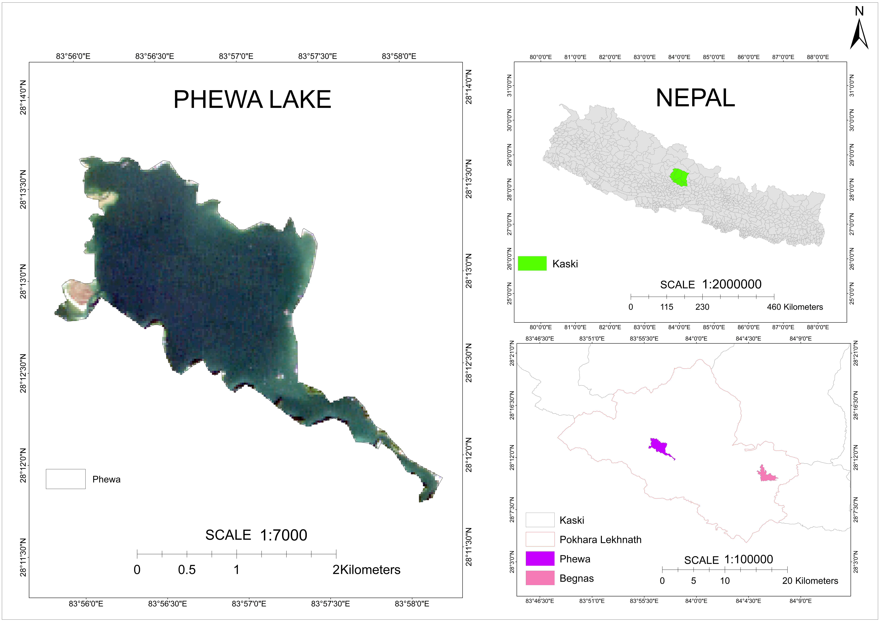

Figure 1: Phewa Lake

Begnas Lake is the third largest lake in Nepal. It is situated 677 meters above sea level and lies 15km east of Lakeside (Phewa Lake area). It covers 27 sq.km (225 hectares of land) and is 7.5 m deep. This lake is used for boating, kayaking, fishing and swimming. The geographical coordinate of Begnas Lake is 28.1739° North and 84.0973° East.

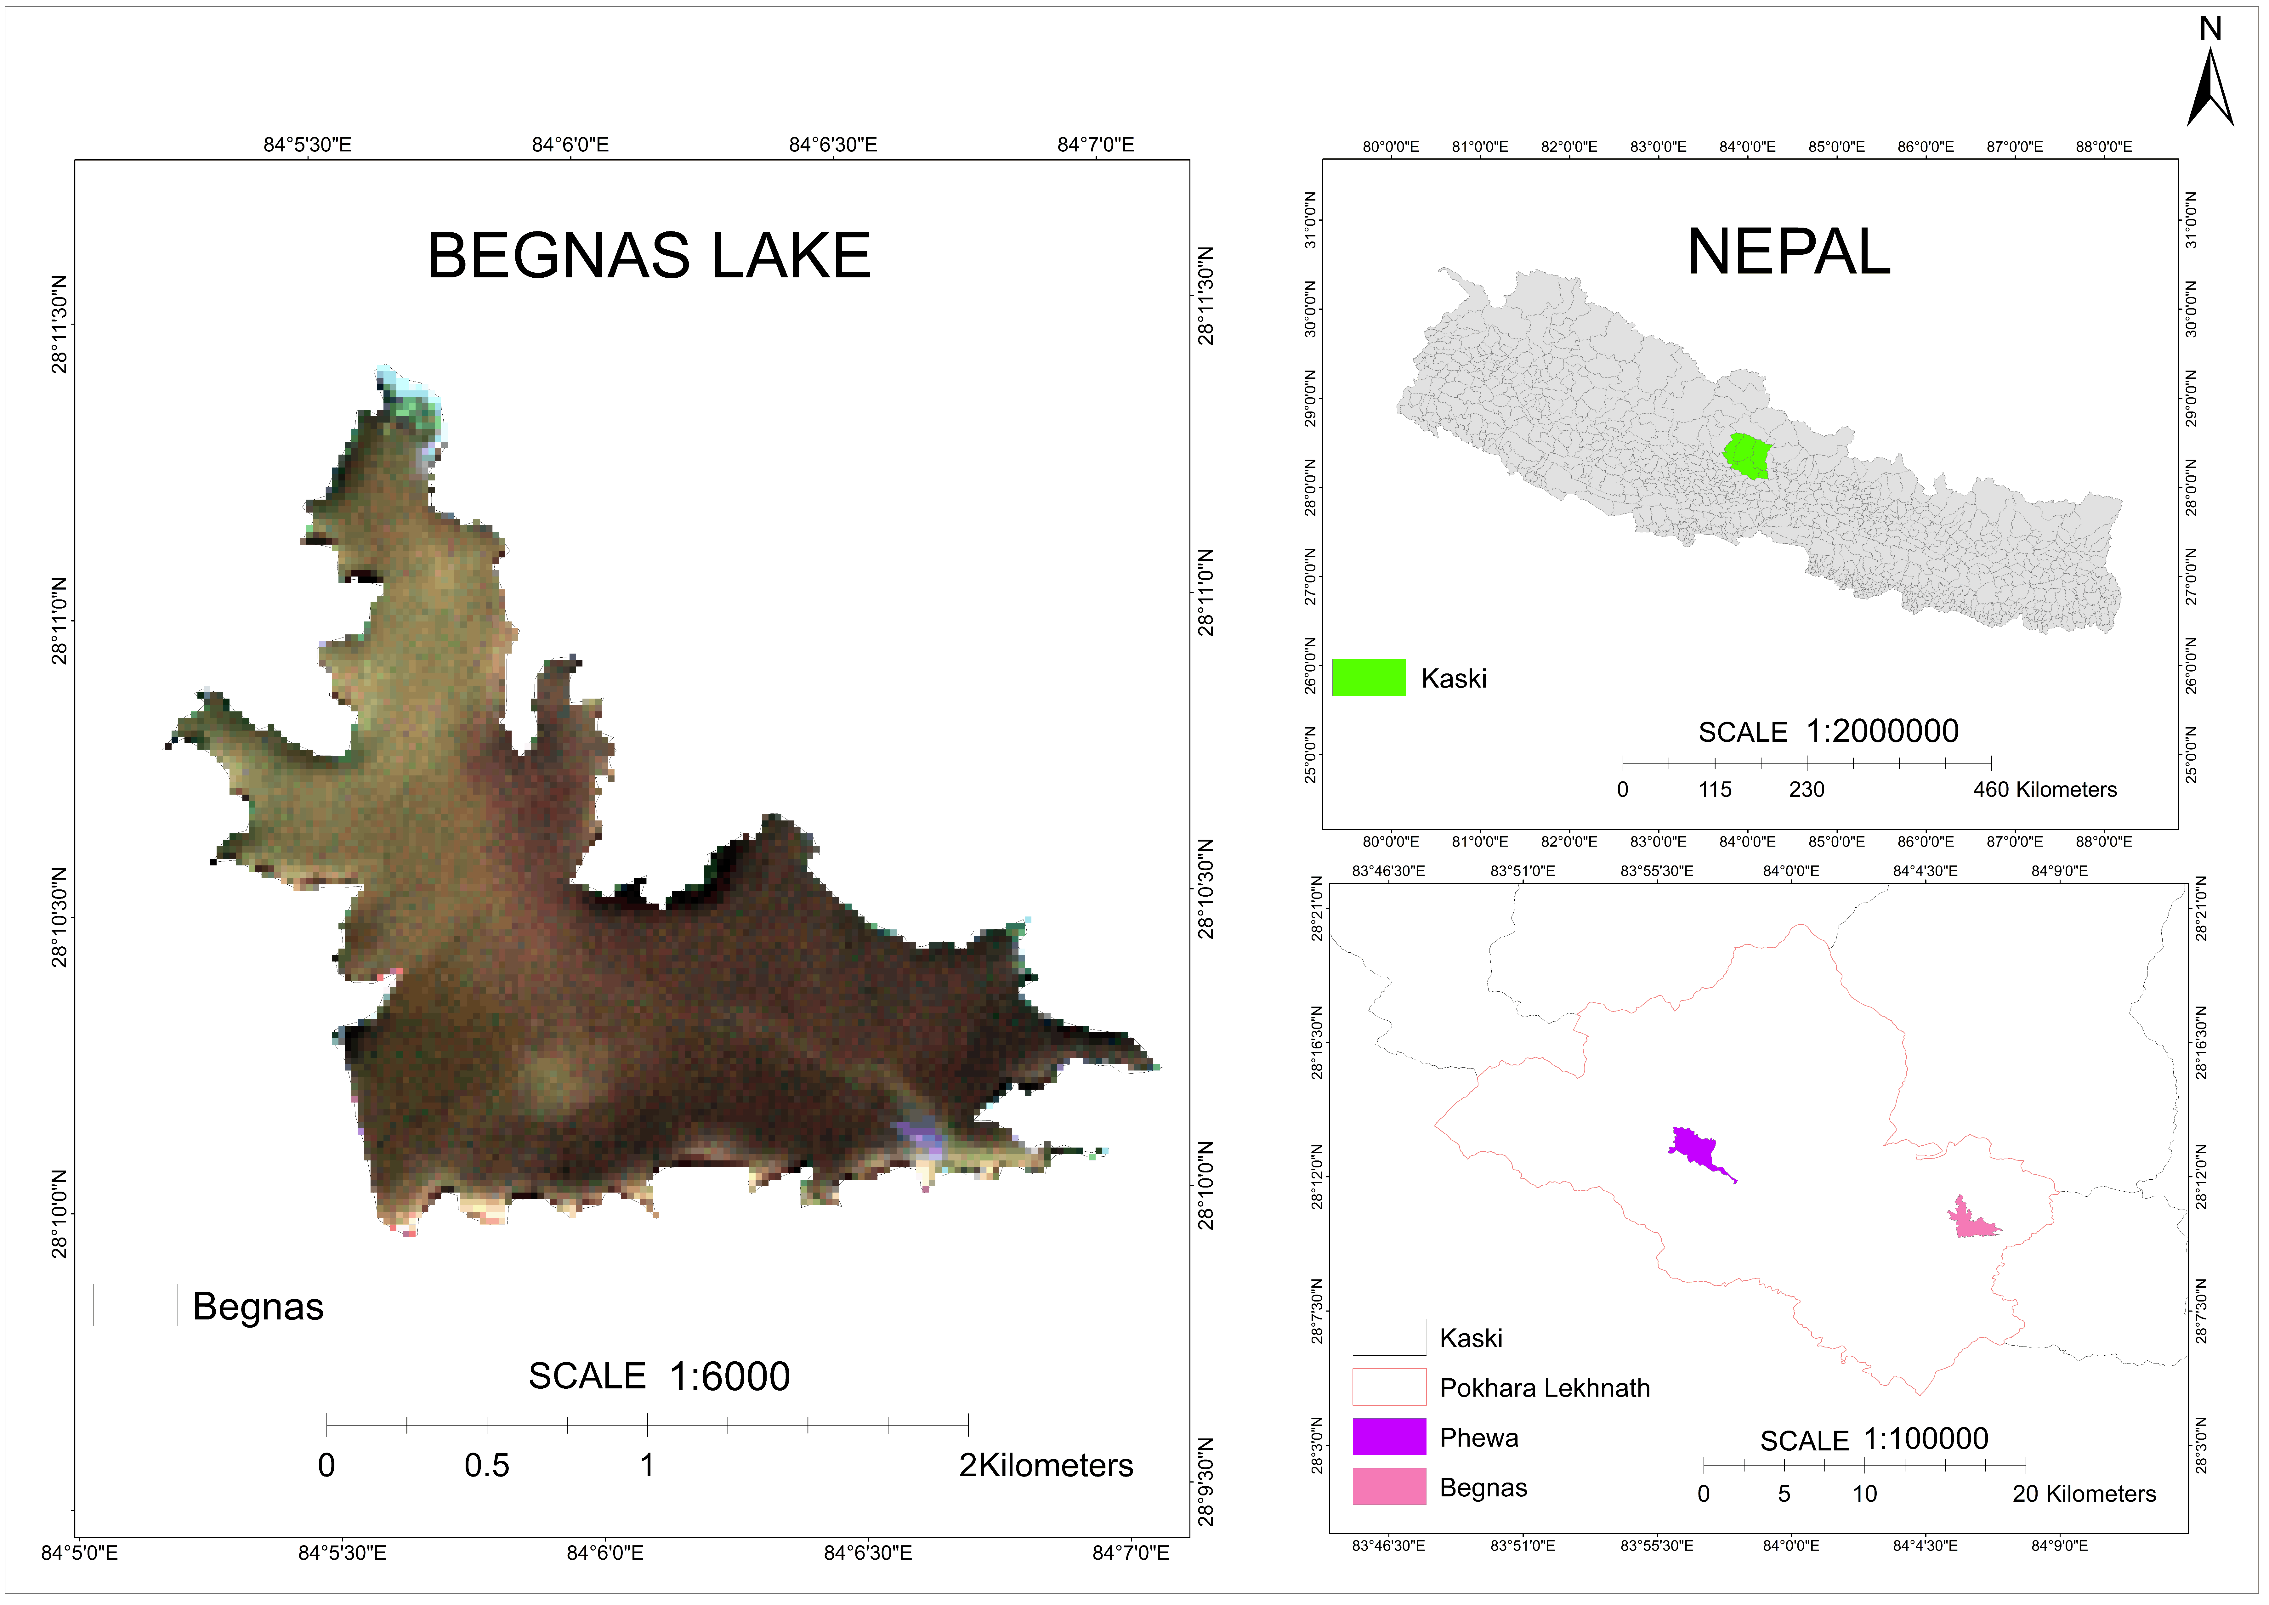

Figure 2: Begnas Lake

## Scope of Study

This project aims to monitor water quality using remote sensing and GIS. This can be very helpful for aquaculture by considering the factors associated with more production of fishes. Water plays vital role to increase the food production also. This study uses RS technology so that it will help to reduce cost as well as time to monitor the water quality of lake.

Furthermore, our project will provide continuously updated information about water quality of lake so that it will help the decision makers in taking the right action at the right time to protect water bodies.

## Limitations

* Sample collection and handling: Proper sample collection and handling are essential for accurate water quality analysis. Any errors or contamination during the collection process can lead to inaccurate results.
* Analytical methods: Different analytical methods can produce different results, and some methods may not be sensitive enough to detect low levels of contaminants.
* Time and cost: Water quality analysis can be time-consuming and expensive, especially for large-scale or frequent testing.
* Interference from natural substances: Natural substances such as algae and sediment can interfere with water quality analysis, making it difficult to detect certain contaminants.
* Lack of data: In some cases, there may be limited data available on the types and levels of contaminants in a particular water source, which can make it challenging to assess the water quality.
* Emergent contaminants: Some contaminants, such as micro plastics and emerging contaminants like pharmaceuticals and personal care products, can be difficult to detect and quantify using current analytical methods.

It is essential to understand the limitations associated with water quality analysis and to use multiple methods to ensure the accuracy and reliability of the results.

# 

# Chapter 2 LITERATURE REVIEW

One of the most important natural resources for eco-sustainability is water, which is likely to become critically scarce in the coming decades due to rising demand, the rapid urbanization of the world's population, the expansion of agriculture, and industrial activity, particularly in dry regions. Water bodies have suffered as a result of the rise in anthropogenic activity in recent decades, particularly in industrial areas. As a result, rivers may be less able to support aquatic life or have less capacity to store water. The amount of industrial waste and sewage discharged into rivers has significantly increased as a result of industrialization and urbanization. In comparison to quantity, water quality issues have grown in importance. Future water shortages are anticipated to be far worse than they have been in recent years. In areas where conventional monitoring techniques are either absent or insufficient, remote sensing has the ability to estimate the concentrations of SWQPs on inland waters and estuaries.

## 2.1 Factors Defining Water Quality

Water is a precious resource. Not only does it provide us with life-sustaining hydration, but water also has a profound impact on the quality of our lives. There are various parameters affecting the quality of water. These water quality parameters can be divided into two types:

### 2.1.1 Optical Parameters

The features of water that affect how it responds to light are referred to as its optical parameters. Properties like absorbance, scattering, and fluorescence can be among these factors. The presence and quantity of several pollutants, such as suspended particles, dissolved organic matter, and nutrients, as well as the clarity and colour of water, can all be determined using optical characteristics of water. Water's optical characteristics can be used to track changes in water quality over time and to locate probable pollution sources or other environmental problems (Mishra, 2011).

1. **Turbidity**

The measurement of turbidity is a key test of both water clarity and water quality. Turbidity is the measure of relative clarity of a liquid. It is an optical characteristic of water and is a measurement of the amount of light that is scattered by material in the water when a light is shined through the water sample. Higher the intensity of scattered light, higher will be the turbidity. It is measured in ppm (mg/litre) (EPA, 1986) .

1. **Total Suspended Solids (TSS)**

TSS is the dry weight of suspended particles that are not dissolved. TSS can include a wide variety of material, such as silt, decaying plant and animal matter, industrial wastes, and sewage. High concentrations of suspended solids can cause many problems for stream health and aquatic life. It is measured in ppm (mg/litre) (Joseph M. Moran, 1986).

### 2.1.2 Non-optical Parameters

The qualities of water that are not directly related to how it responds to light are referred to as non-optical parameters of water. The physical, chemical, and biological characteristics of water can be among these factors (Glibert, 2016).

1. **Total Dissolved Solids (TDS)**

TDS is a measure of the dissolved combined content of all inorganic and organic substances present in a liquid molecular, ionized, or micro-granular suspended form. TDS is a measure of the dissolved combined content of all inorganic and organic substances present in a liquid molecular, ionized, or micro-granular suspended form. TDS can affect the taste, odour, and clarity of water, and can also have health implications. It is measured in ppm (mg/litre) (LLC., 2022) .

1. **Dissolved Oxygen (DO)**

Dissolved oxygen (DO) is a measure of how much oxygen is dissolved in the water. The amount of oxygen available to living aquatic organisms. The amount of dissolved oxygen in a stream or lake can tell us a lot about its water quality. DO is considered an important measure of water quality as it is a direct indicator of an aquatic resource’s ability to support aquatic life. It is measured in ppm (mg/litre) (WSS, 1994).

1. **Potential of Hydrogen (pH)**

pH is a measure of how acidic/basic water is. Water that has more free hydrogen ions is acidic, whereas water that has more free hydroxyl ions is basic. Since pH can be affected by chemicals in the water, pH is an important indicator of water that is changing chemically (WSS, 1994).

## 2.2 Sentinal-2A Satellite Image

Sentinel-2 is a Copernicus Program Earth observation project that routinely gathers optical pictures at high spatial resolution (10 m to 60 m) over land and coastal waterways. Sentinel-2A and Sentinel-2B are the two satellites already in the constellation for the mission; testing is currently taking on for Sentinel-2C in preparation for launch in 2024. Sentinel-2 will have an optical payload with 13 spectral bands of visible, near-infrared, and shortwave infrared sensors, with 4 bands at 10 meters, 6 bands at 20 meters, and 3 bands at 60 meters of spatial resolution (ESA, 1975).

On June 23, 2015, a Vega launcher from the spaceport successfully launched the Sentinel-2A satellite sensor. The Sentinel-2A satellite, the first optical Earth observation satellite in the European Copernicus program, was created and assembled for the European Space Agency (ESA) by Airbus Defence and Space. Due to its excellent geographical and temporal resolution and three red edge bands, the Sentinel-2A satellite will be able to detect very early changes in plant health. For agricultural applications and the early detection of food shortages in poor nations, this is especially helpful for end users and policymakers (ESA, 1975).

Four visible and near-infrared bands (B2, B3, B4, and B8) that can be used to assess the quality of water are carried by the Sentinel 2A satellite's multispectral imager, which can collect data in 13 spectral bands. Four visible and near-infrared bands (B2, B3, B4, and B8) that can be used to assess the quality of water are carried by the Sentinel 2A satellite's multispectral imager, which can collect data in 13 spectral bands (GISGeography, 2022).

Table 1:Bands of Sentinel-2A

|  |  |  |  |
| --- | --- | --- | --- |
| Sentinel-2 Bands | Wavelengths (micrometres) | Resolution (meter) | Uses |
| Band 1- Coastal aerosol | 0.443 | 60 | To map coastal vegetation and aquatic ecosystem. |
| Band 2- Blue | 0.490 | 10 | To map water quality, vegetation and urban areas. |
| Band 3- Green | 0.560 | 10 | To map vegetation health, land cover monitor crops. |
| Band 4- Red | 0.665 | 10 | To map health of vegetation, track crop growth and spot stressed vegetation. |
| Band 5-Vegetation Red Edge | 0.705 | 20 | To signal change in health of vegetation, leaf area index, water content of plants. |
| Band 6-Vegetation Red Edge | 0.740 | 20 | To map health and leaf area index of vegetation. |
| Band 7-Vegetation Red Edge | 0.783 | 20 | Same as band 5 and 6. |
| Band 8- NIR | 0.842 | 10 | Used for mapping vegetation health, leaf index areas with high atmospheric moisture. |
| Band 8A -Vegetation Red Edge | 0.865 | 20 | Sensitive to atmospheric water vapour and affects quality of satellite images. |
| Band 9- Water Vapour | 0.945 | 60 | Sensitive to presence of high-altitude cirrus clouds; affects satellite imagery. |
| Band 10- SWIR- cirrus | 1.375 | 60 | Sensitive to SWIR radiation by vegetation; used for mapping vegetation health and moisture content. |
| Band 11- SWIR | 1.610 | 20 | Sensitive to SWIR radiation by soil; used for mapping soil moisture content. |
| Band 12- SWIR | 2.190 | 20 | Sensitive to reflection of SWIR radiation by soil; used for mapping soil moisture content, land cover mapping and geological mapping. |

*Source: Satellite Imaging Corporation*

By employing specific sampling points, in-situ measurements have historically been able to acquire exact water quality data, however this method is time-consuming, labour-intensive, expensive, and has limitations for large-scale monitoring (Blake A. Schaeffer, 2013). Remote sensing technology has been utilized to reflect the spatial distribution and dynamic changes in water quality components due to the benefits of spatial and temporal coverage (K. Kallio, 2001) . Different space borne sensors with visible, infrared, and microwave wavelengths can be utilized to monitor water quality due to high frequency data collecting and large-scale coverage. In the VIS and IR domains, a variety of spectral remotely sensed data have been successfully and widely used in retrieving water quality. In the microwave domain, radiometers and synthetic aperture radars may be marginally helpful in the estimation of sea surface temperature and sea surface salinity (Zhang, 2003).

Although the capabilities of remote sensing to assess water quality are undeniable, this technique alone is not sufficiently precise and must be used in conjunction with traditional sampling methods and field surveying. In other words, to obtain a better insight, an integrated use of remote sensing, in-situ measurements and computer water quality modelling may lead to an increased knowledge of the water quality of water systems. Collaboration between different governmental, federal and private agencies and data sharing is also helpful to increase the data required for regional studies. Kallio (K. Kallio, 2001) has mentioned four advantages of applying remote sensing in compliance with other water quality monitoring programs as below:

* Gives a synoptic view of the entire waterbody for more effective monitoring of the spatial and temporal variation.
* Makes it possible to have a synchronized view of the water quality in a group of lakes over a vast region.
* Provides a comprehensive historical record of water quality in an area and represents trends over time.
* Prioritizes sampling locations and field surveying times.

## 2.3 Approaches for Water Quality Parameters Estimation

For more than ten years, monitoring water quality has been a common application of the remote sensing approach. Various methods for estimating the characteristics of water quality are developed throughout this time. Basically, they can be divided into three methodologies:

### 2.3.1 Empirical Approach

The empirical approach is a kind of correlation statistical regression formula, which can be established by using a ground-measured water quality parameter value and reflectance of the optimal band or combination of bands. The advantage of the empirical mode is that it is simple and easy to operate, and can be refined by selecting more precise spectral channels to increase the accuracy of water quality parameters retrieval. However, the empirical mode has three obvious disadvantages. Firstly, it is hard for simple empirical models to meet the accuracy requirements of water quality parameters concentration estimation because the related spectral characteristics are mainly affected by the complex composition of water quality variables including phytoplankton pigments and CDOM etc., which bring great uncertainty to the inversion of water quality concentration. Secondly, due to regional and temporal constraints, empirical models have poor generalities and the established models in a certain water area may not be applicably used in other regions. Finally, the empirical approaches requires a lot of field water quality sampling data as the basis to assure a relatively higher accuracy (Haibo Yang, 2022).

### 2.3.2 Analytical Approach

The analytical approach uses bio-optical models and radiation transmission models to simulate the propagation of light in the atmosphere and water bodies to describe the relationship between water quality components and the radiance or reflection spectrum of off-water radiation. In 1975, Gordon et al. proposed the general relationship between the apparent optical reflectance and water properties in water bodies (Howard R. Gordon, 1975). This kind of quasi-single-scattering diffuse reflectance model represents an important foundation for the development of the analytical model as follows:

$R_{rs}=f\left[\frac{b_{b}\left(λ\right)}{a\left(λ\right)+b_{b}\left(λ\right)}\right]$ (1)

Where, $R_{rs}$ is the reflectance, $λ$ represents the wavelength, $a$ is the total absorption coefficient of water, $b_{b}$ is the total backscattering coefficient of water, and $f$ is the functional relation (Haibo Yang, 2022).

## 2.3.3 Semi-empirical Approach

The semi-empirical approach is a combination of the empirical mode and the analytical mode. By using a certain paradigm derived from rigorous analytical models, SEM has a good applicability to calculate the water quality variables by combining only a small amount of in-situ data and reflectance or radiance values. Some scholars used this method to retrieve water quality components such as Chl-a, CDOM and associated visibility and turbidity with higher accuracies .As for the study of suspended matter concentration retrieval, Lathrop, found that the SPOT-1 R band and NIR band were more sensitive to the suspended matter concentration, so they calculated different concentrations with RG band ratio and NIR band based on the SE approach. The semi-empirical method considers the optical characteristics of water quality parameters and has better portability than the empirical method (Haibo Yang, 2022).

## 2.4 Feature Selection

Feature selection is also called as variable selection. In a statistical or machine learning model, the act of selecting the most crucial variables—also known as predictors or features—that significantly influence a target variable or outcome. Reducing the number of variables while maintaining or enhancing the model's accuracy and interpretability is the aim of variable selection (Isabelle Guyon, 2003).

### 2.4.1 Multicollinearity

When two or more predictor variables have a high degree of correlation with one another, multicollinearity-an issue that can arise in regression analysis-can happen. Because even tiny changes in the data might result in significant changes in the regression coefficients, this can make the coefficients unstable and challenging to understand (Michael H. Kutner, 2005).

### 2.4.2 Correlation with Target

In data analysis and machine learning, correlation with the target variable refers to the relationship between a predictor variable and the outcome variable. The strength and direction of this relationship can help us determine the predictive power of the predictor variable. Most of the review shows that there must be correlation at least 0.3 with the target variable (r<0.5) (Gareth James, 2021).

### 2.4.3 Step-Wise Regression

Stepwise regression is a technique for selecting variables in regression analysis that incrementally adds or subtracts variables from the model depending on their statistical significance. It is a kind of backward selection strategy in which variables are initially added to the model and subsequently dropped if it is determined that they are not significant.

There are two types of step-wise regression methods: forward step-wise regression and backward stepwise regression. Stepwise regression can be an effective way to select variables in regression analysis, as it can quickly identify the most important predictors and improve the model's accuracy. However, it has some limitations, such as the risk of overfitting and the potential for selecting variables based solely on their statistical significance without considering their practical significance or relevance. Therefore, it is important to use caution when using step-wise regression and to consider other variable selection methods and model evaluation techniques as well (Michael H. Kutner, 2005).

## 2.5 Random Sampling Techniques

Random sampling is a widely used technique in water sample collection for water quality analysis. The goal of random sampling is to obtain representative samples of the water body of interest, while minimizing bias and ensuring that each part of the water body has an equal chance of being sampled (Cochran, 1991).

Here are some common steps involved in the random sampling process for water sample collection:

* Determine the sampling locations: The sampling locations should be selected randomly and should represent the entire water body of interest. The number of sampling locations should be determined based on the size and complexity of the water body.
* Determine the sampling frequency: The sampling frequency should be determined based on the temporal variability of the water quality parameters of interest. For example, if the water quality parameters vary significantly throughout the required time, more frequent sampling may be required.
* Collect the water samples: The water samples should be collected using clean sampling equipment and containers to avoid contamination.
* Record the sample location and other relevant information: It is important to record the sample location, depth, and other relevant information to facilitate data analysis and interpretation.
* Analyse the water samples: The water samples should be analysed in a laboratory using standard methods to determine the water quality parameters of interest.

# 

# Chapter 3 METHODOLOGY

## 3.1 Workflow

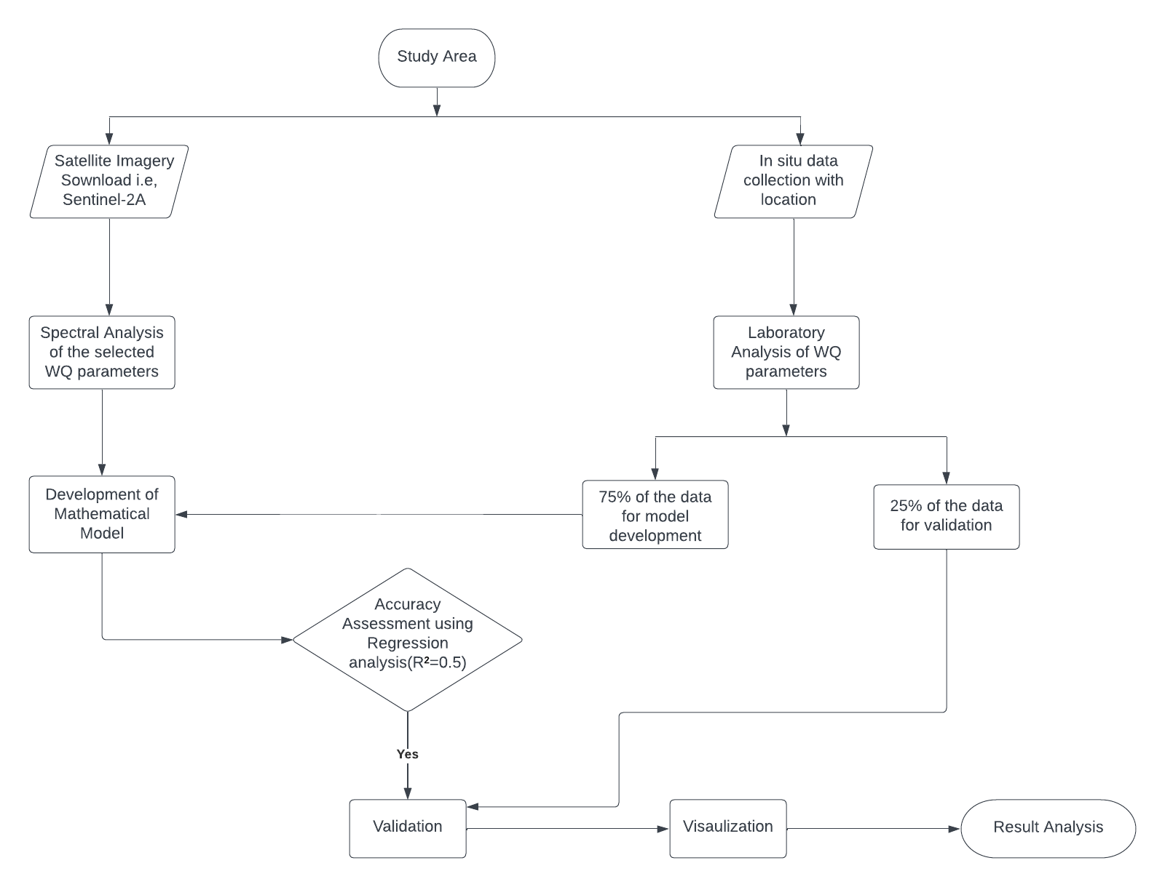

Figure 3: A framework to predict and assessment of water quality variable

## 3.2 Laboratory Methods

### 3.2.1 In-situ Water Sample Collection

To continuously evaluate the quality of the water coming from the various supply sources, both qualitative and quantitative measurements are occasionally required. Water sampling, testing, and investigative analysis are all part of water quality monitoring, which is integrated into crucial treatment processes. To cover all elements of the lake water, water was gathered from various sources including the human activity zone, hill zone, forest zone, agricultural region, boating zone, sewerage area, etc.

The GPS receiver, OSM tracker was used to record the precise locations where the samples were taken.

Altogether, 22-26 samples were taken from each lakes and the locations were determined using random sampling technique.

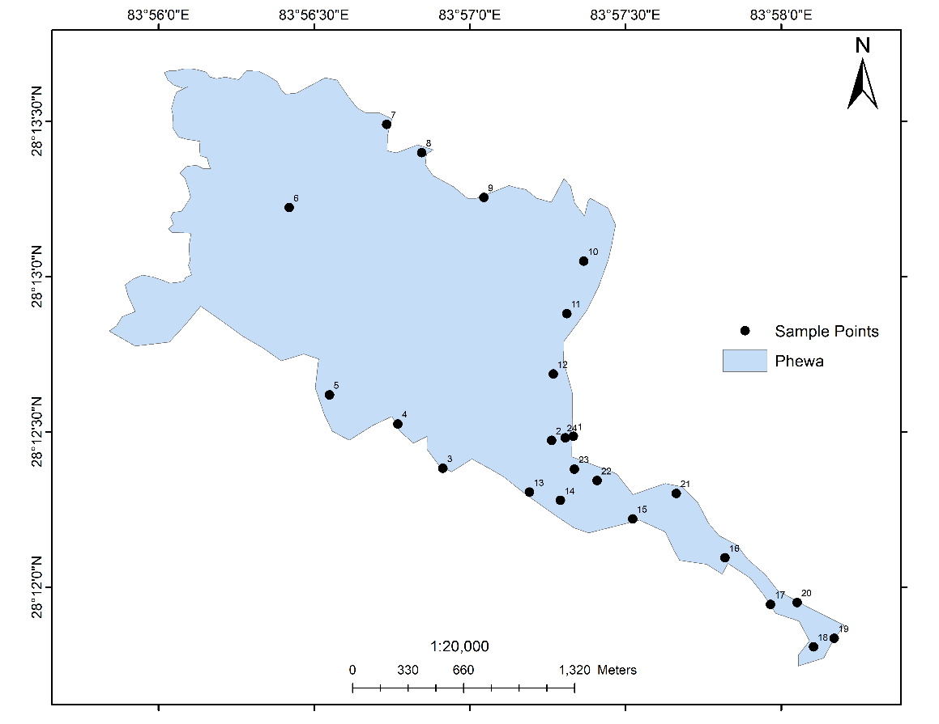

Figure 4: Sample locations in Phewa Lake (November 2022)

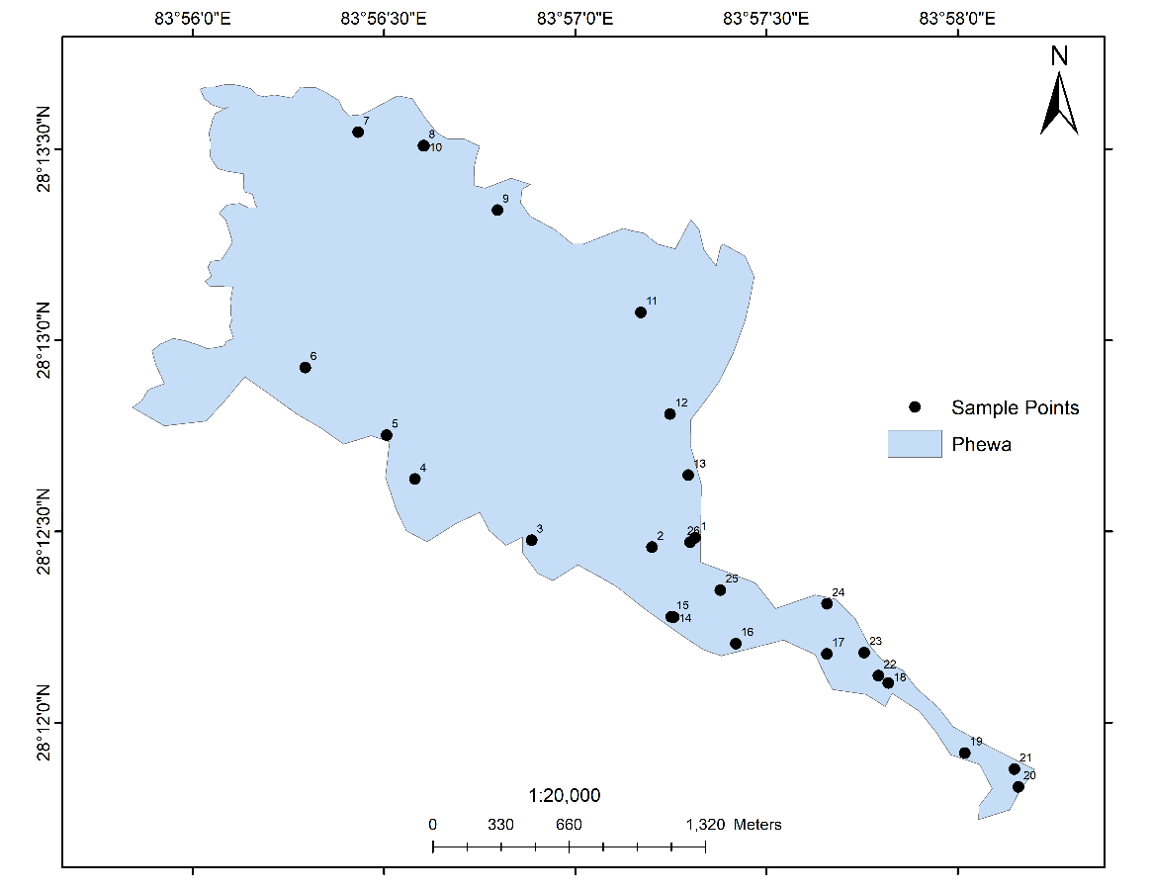

Figure 5: Sample locations for Phewa Lake (February 2023)

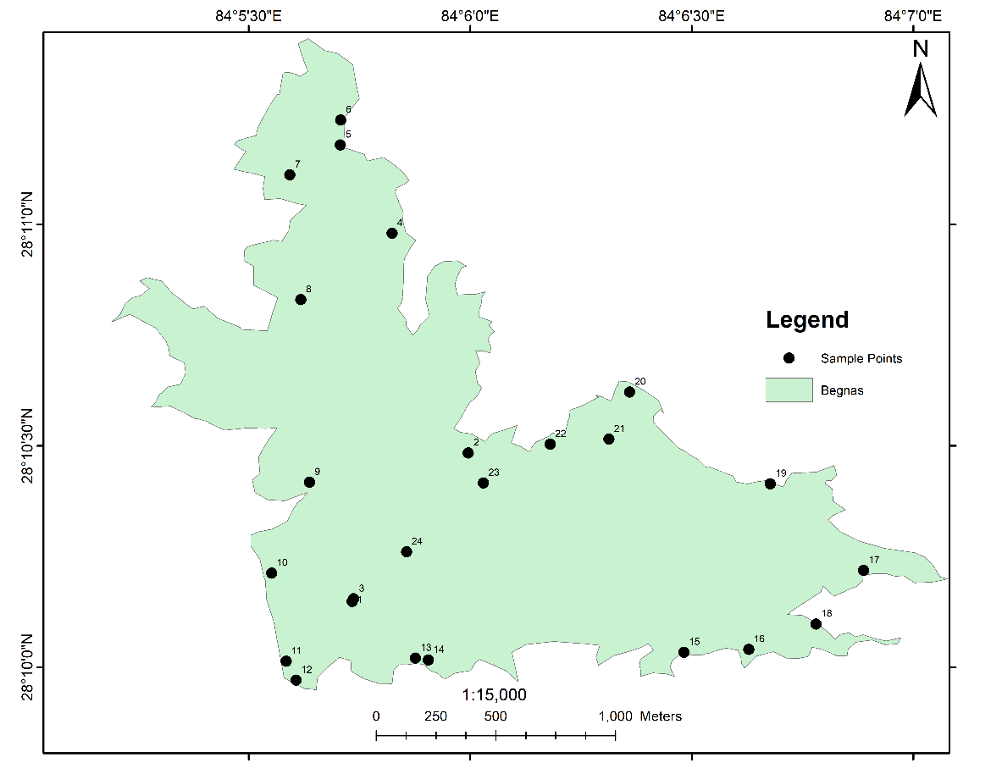

Figure 6: Sample locations for Begnas Lake (November 2022)

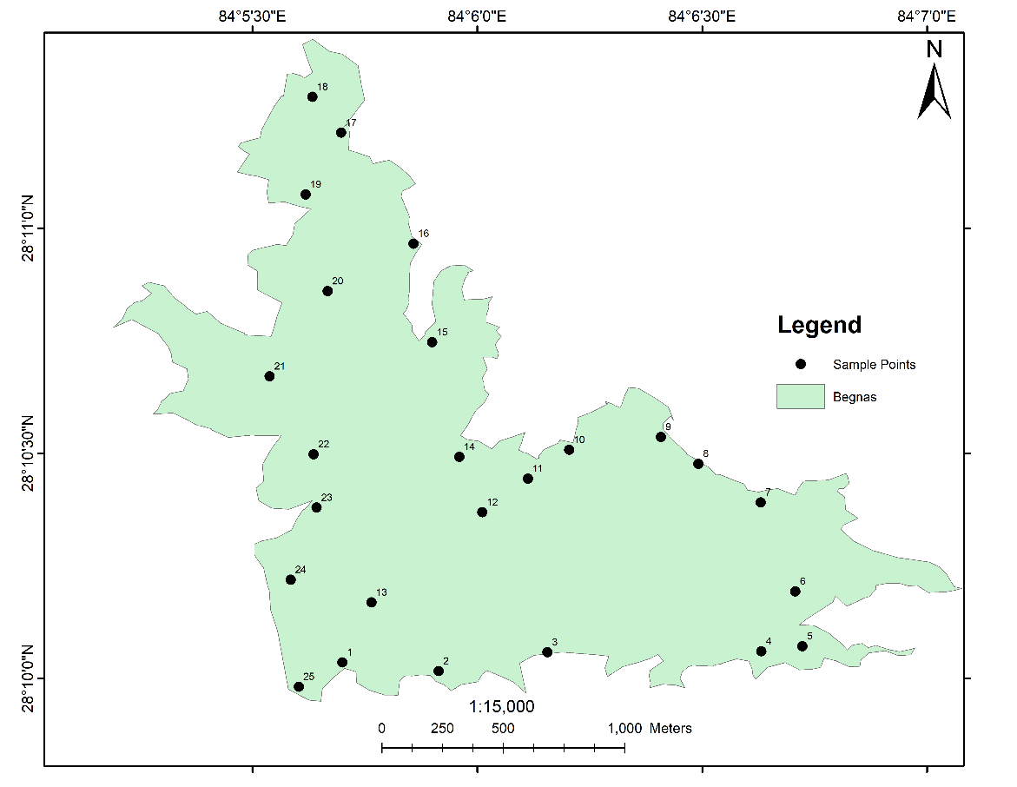

Figure 7: Sample locations for Begnas Lake (Janaury 2023)

### 3.2.2 Laboratory Examination

Concentration of turbidity, Total Suspended Solids (TSS), Total Dissolved Solids (TDS) and Dissolved Oxygen (DO) were measured according to the standard methods for lab examination of water.

1. **Turbidity**

Turbidity of all samples were measured using turbidity tube. Turbidity tube is a tube with a black cross at the bottom and the measurement is done by pouring water into the tube until they can no longer make out the red cross at which point we can read off the scale on the outside of the tube in NTU. Turbidity samples are tabulated in Table 2:

Table 2: Turbidity Result Samples of Begnas lake (January 2023)

|  |  |  |
| --- | --- | --- |
| Sample points | Area | Obtained Turbidity |
| 1 | Forest area | 24.86 |
| 2 | Forest residue area | 25.27 |
| 3 | Agriculture area | 25.2 |
| 4 | Resort area | 25.75 |
| 5 | Majhikuna | 22.67 |

1. **TSS**

Test of TSS has been done by pouring a carefully measured volume of sample water (5ml) through the pre-weight filter paper then weighing the filter paper with residue again after drying process that removes all water on the filter. TSS of samples are tabulated in Table 3:

Table 3: TSS Result Samples of Begnas lake (January 2023)

|  |  |  |
| --- | --- | --- |
| Sample points | Area | Obtained TSS |
| 1 | Forest area | 3000 |
| 2 | Forest residue area | 3000 |
| 3 | Agriculture area | 2900 |
| 4 | Resort area | 3100 |
| 5 | Majhikuna | 2800 |

1. **TDS**

Gravimetric method has been done to find TDS. Measurement of TDS involves evaporating the liquid solvent and measuring the mass of residues. TDS of samples are tabulated in Table 4:

Table 4: TDS Result Samples of Begnas lake (January 2023)

|  |  |  |
| --- | --- | --- |
| Sample points | Area | Obtained TDS |
| 1 | Forest area | 3000 |
| 2 | Forest residue area | 3000 |
| 3 | Agriculture area | 3000 |
| 4 | Resort area | 3000 |
| 5 | Majhikuna | 2900 |

1. **pH**

A phenolphthalein indicator is added to a fresh portion of sample. The colour of the sample changes immediately in response to the pH of sample. The pH is estimated by comparison with colour standards.

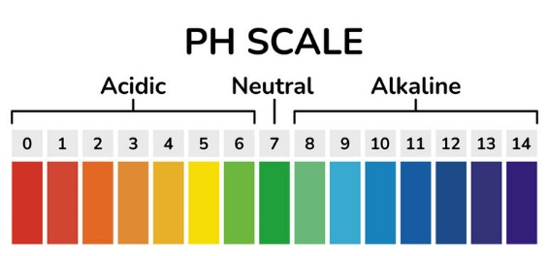

Source: USGS

Figure 8: pH Scale

The pH of samples are tabulated in Table 5:

Table 5: pH Result Samples of Begnas lake (January 2023)

|  |  |  |
| --- | --- | --- |
| Sample points | Area | Obtained pH |
| 1 | Forest area | 6.9 |
| 2 | Forest residue area | 7.1 |
| 3 | Agriculture area | 6.5 |
| 4 | Resort area | 7 |
| 5 | Majhikuna | 6.9 |

1. **DO**

DO was determined by taking 100ml water sample and adding 2ml each of KI (Potassium Iodide) and MnSO₄ (Manganese Sulphate) to the solution. The NaOH (Sodium Hydroxide) was added to the mixture to get brown precipitation. Then, 6ml of 12N H₂SO₄ was added and the mixture was shaked until the precipitation dissolved. After adding 2ml starch solution to the mixture, the final solution was titrated with 0.1N Sodium Thiosulphate solution until the solution turned colourless. The volume of Sodium Thiosulphate was observed in burette and calculations were performed to get DO in mg/litre (ppm). The DO of the samples are tabulated in Table 6:

Table 6: DO Result Samples of Begnas lake (January 2023)

|  |  |  |
| --- | --- | --- |
| Sample points | Area | Obtained DO |
| 1 | Forest area | 8 |
| 2 | Forest residue area | 7.6 |
| 3 | Agriculture area | 7 |
| 4 | Resort area | 8.8 |
| 5 | Majhikuna | 7.6 |

## 3.3 Remote Sensing Method

### 3.3.1 Satellite Imagery of Study Area (Download)

The satellite image for the project was primarily from Sentinel-2A which is freely available in the Copernicus Open Access Hub. The satellite images of the study area were downloaded with less than 20% cloud cover for the same day when samples were collected.

### 3.3.2 Signature Preparation:

Using ArcGIS software, the pixel values of each sample point were retrieved from the downloaded satellite pictures for the associated lakes for the estimation of various parameters. The correlation coefficient was determined between the pixel values and various satellite images bands. The computed correlation coefficients were used to choose appropriate bands for the model construction using R-studio software.

The samples of the pixel values of the taken points are tabulated in Table 7:

Table 7: Pixel values of sample points of Phewa (November)

|  |  |  |  |  |  |  |  |  |  |  |
| --- | --- | --- | --- | --- | --- | --- | --- | --- | --- | --- |
| Sample points | band 1 | band 2 | band 3 | band 4 | band 5 | band 6 | band 7 | band8a | band 11 | band 12 |
| 1 | 1408 | 1673 | 1813 | 1839 | 1955 | 2357 | 2449 | 2516 | 2375 | 2032 |
| 2 | 1259 | 1265 | 1397 | 1200 | 1159 | 1101 | 1113 | 1122 | 1083 | 1067 |
| 3 | 1306 | 1350 | 1494 | 1229 | 1173 | 1140 | 1276 | 1242 | 1211 | 1103 |
| 4 | 1271 | 1264 | 1370 | 1180 | 1182 | 1205 | 1058 | 1058 | 1164 | 1063 |
| 5 | 1222 | 1229 | 1298 | 1150 | 1121 | 1106 | 1149 | 1122 | 1074 | 1052 |
| 6 | 1224 | 1243 | 1301 | 1156 | 1121 | 1092 | 1102 | 1073 | 1041 | 1027 |
| 7 | 1417 | 1315 | 1439 | 1251 | 1221 | 1179 | 1316 | 1238 | 1357 | 1197 |
| 8 | 1277 | 1262 | 1433 | 1250 | 1258 | 1183 | 1262 | 1229 | 1217 | 1110 |
| 9 | 1302 | 1356 | 1570 | 1417 | 1681 | 1974 | 2021 | 2236 | 2013 | 1625 |
| 10 | 1231 | 1260 | 1394 | 1183 | 1160 | 1105 | 1111 | 1091 | 1065 | 1055 |

### 3.3.3 Model Development

The SWR method selects a sub-set from a list of independent variables and removes and adds variables to the regression model for the purpose of identifying a useful sub-set of the predictors. Sampling points were subdivided into two datasets; calibration (75% of all samples) and validation (25% of all samples) to establish and validate the developed models.

### 3.3.4 Accuracy Assessment

Accuracy assessment is a critical step in the evaluation of water quality analysis. The accuracy of water quality analysis refers to how close the obtained value from lab is to the estimated value of a parameter from the developed model. Remaining 25% of samples were used to validate the estimated values. It is important to assess the accuracy of water quality analysis to ensure that the data obtained is reliable and can be used for making informed decisions.

Concentrations of the parameters were estimated using the developed models and the accuracy measures for each parameters were R²>0.5 which was the acceptable limit.

### 3.3.5 Map Preparation

The results obtained from the developed model for each parameters were used to generate maps using ArcGIS. Maps were prepared to compare the concentration of parameters according to the time when data were collected. To stretch data for better visibility, percentage clip was employed. In order to make the maps user-friendly, elements were added and employed in accordance with the principles of cartography.

# 

# Chapter 4 RESULTS AND DISCUSSION

## 4.1 Laboratory Results

The test results showed that for different points the value of parameters differs more or, less. pH of the Phewa lake was found to be somehow close to neutral. The water around Barahi temple was found to be more acidic and that of the hotel areas were basic. Turbidity in water was higher in paragliding area and lower around parks. DO was observed to be higher around forest areas and lower around hotel areas. TDS and TDS were found to be higher around paragliding area and lower around forest areas.

Table 8: Laboratory results of parameters of Phewa lake (November 2022)

|  |  |  |  |  |  |  |  |  |
| --- | --- | --- | --- | --- | --- | --- | --- | --- |
| points | Area | Latitude | Longitude | Turbidity | TSS | TDS | pH | DO |
| 1 | Barahi Temple | 28.2081 | 83.95554 | 27.84 | 3500 | 4660 | 6 | 10.2 |
| 2 | Forest area | 28.20788 | 83.95438 | 28.41 | 2700 | 2000 | 6.9 | 8.8 |
| 3 | Center area | 28.20638 | 83.94856 | 25.89 | 2200 | 3000 | 7.3 | 7.8 |
| 4 | Forest area | 28.20876 | 83.94615 | 29.36 | 2300 | 2500 | 6.1 | 9.6 |
| 5 | Hotel area | 28.21032 | 83.94249 | 28.05 | 2600 | 2500 | 6.3 | 6.6 |
| 6 | Center area | 28.22037 | 83.94034 | 28.35 | 2200 | 2100 | 6.5 | 9.2 |
| 7 | Hotel area | 28.22483 | 83.94555 | 28.75 | 2300 | 3300 | 6.2 | 7.5 |
| 8 | Agriculture area | 28.22331 | 83.94743 | 29.27 | 2400 | 2200 | 6.1 | 9.6 |
| 9 | Paragliding area | 28.22091 | 83.95075 | 31.15 | 3200 | 3600 | 8.6 | 10.4 |
| 10 | Disneyland area | 28.21749 | 83.9561 | 24.71 | 2400 | 2000 | 6.8 | 9.2 |
| 11 | Fishing area | 28.21468 | 83.95519 | 26.47 | 2500 | 2000 | 6 | 10 |
| 12 | Hotel area | 28.21144 | 83.95447 | 29.84 | 2600 | 2500 | 7.1 | 7.2 |
| 13 | Forest area | 28.2051 | 83.95319 | 30.6 | 2000 | 2700 | 7.2 | 10 |
| 14 | Center area | 28.20466 | 83.95485 | 25.16 | 2500 | 2500 | 7.3 | 10.1 |
| 15 | Forest area | 28.20367 | 83.95872 | 30.31 | 2300 | 2300 | 6.7 | 7.4 |
| 16 | Fishtail lodge | 28.20158 | 83.96366 | 29.86 | 2800 | 2700 | 8.7 | 10.4 |
| 17 | Forest area | 28.19908 | 83.9661 | 29.43 | 2300 | 2700 | 7.3 | 9.8 |
| 18 | Damside | 28.1968 | 83.9684 | 29.23 | 2400 | 2500 | 8.3 | 7.2 |
| 19 | Boating area | 28.19726 | 83.9695 | 30.74 | 3200 | 3600 | 7.2 | 9.2 |
| 20 | Phirke khola | 28.19918 | 83.96752 | 29.7 | 2500 | 3000 | 6.7 | 8.6 |
| 21 | Basundhara park | 28.20503 | 83.96105 | 26.14 | 2600 | 2500 | 6.8 | 10.2 |
| 22 | Gaurighat park | 28.20572 | 83.95681 | 26.55 | 2500 | 2800 | 8.3 | 9.2 |
| 23 | Center area | 28.20633 | 83.9556 | 28.61 | 2400 | 2500 | 7.5 | 6.4 |
| 24 | Boating area | 28.20802 | 83.95511 | 27.43 | 3000 | 3500 | 6.8 | 9.6 |

The test results showed that for different points the value of parameters differs more or, less. pH of water was found to be basic around forest areas and acidic around Barahi temple. The results of turbidity was found to be higher around Barahi temple and lower around Disneyland area. DO was observed to be higher in boating area and lower around dam side. TSS and TDS were found to be higher around hotel areas and lower around forest areas.

Table 9: Laboratory results of parameters of Phewa lake (February 2023)

|  |  |  |  |  |  |  |  |  |
| --- | --- | --- | --- | --- | --- | --- | --- | --- |
| points | Area | latitude | longitude | Turbidity | TSS | TDS | pH | DO |
| 1 | Temple area | 28.2081 | 83.9552 | 29.35 | 3300 | 4000 | 6.5 | 9.6 |
| 2 | Forest area | 28.2077 | 83.9534 | 28.78 | 3100 | 3000 | 7.2 | 7.4 |
| 3 | Hotel area | 28.208 | 83.9481 | 27.87 | 4000 | 4700 | 6.8 | 8.2 |
| 4 | Hotel area | 28.2106 | 83.943 | 27.97 | 3000 | 2900 | 6.4 | 6.6 |
| 5 | Forest area | 28.2125 | 83.9418 | 28.67 | 2600 | 3400 | 7.3 | 5.6 |
| 6 | Center | 28.2155 | 83.9382 | 24.65 | 2800 | 2700 | 6.9 | 6.4 |
| 7 | Hotel area | 28.2257 | 83.9405 | 26.21 | 3000 | 2600 | 6.5 | 6.6 |
| 8 | Center | 28.2252 | 83.9434 | 28.53 | 2800 | 2800 | 7.2 | 5.6 |
| 9 | Agricultural area | 28.2223 | 83.9466 | 27.46 | 2700 | 2500 | 7.6 | 5.6 |
| 10 | Paragliding area | 28.2252 | 83.9434 | 25.48 | 3000 | 2900 | 7.6 | 5.6 |
| 11 | Disneyland area | 28.2179 | 83.9529 | 22.43 | 3000 | 2800 | 8.6 | 6.4 |
| 12 | Fish farming area | 28.2135 | 83.9541 | 22.76 | 2900 | 2500 | 7.5 | 6.4 |
| 13 | Boating area | 28.2108 | 83.9549 | 23.17 | 3100 | 2700 | 6.8 | 9.6 |
| 14 | Forest area | 28.2046 | 83.9543 | 26.99 | 2800 | 2300 | 8 | 5.4 |
| 15 | Forest area | 28.2046 | 83.9542 | 27.01 | 2800 | 2300 | 7.9 | 9.4 |
| 16 | Center | 28.2035 | 83.957 | 27.38 | 3000 | 2800 | 7.6 | 8.8 |
| 17 | fishtail lodge | 28.203 | 83.961 | 26.2 | 3000 | 2900 | 7.3 | 9.6 |
| 18 | Fishing area | 28.2017 | 83.9637 | 27.21 | 3100 | 3000 | 6.5 | 6.4 |
| 19 | Dam area | 28.1987 | 83.967 | 25.36 | 3200 | 2900 | 7.2 | 5.6 |
| 20 | Phirke khola | 28.1972 | 83.9693 | 25.55 | 3300 | 3400 | 6.5 | 6.6 |
| 21 | Fishing area | 28.198 | 83.9692 | 24.08 | 4000 | 3400 | 6.6 | 5.6 |
| 22 | Basundhara park | 28.2021 | 83.9632 | 24.08 | 3100 | 3200 | 6.9 | 9.6 |
| 23 | Boating area | 28.2031 | 83.9626 | 26.27 | 3000 | 3100 | 6.7 | 8 |
| 24 | Gaurighat park | 28.2052 | 83.961 | 27.87 | 3200 | 3100 | 6.8 | 7.2 |
| 25 | Center | 28.2058 | 83.9563 | 27.01 | 2900 | 2800 | 7.8 | 5.6 |
| 26 | Boating area | 28.2079 | 83.955 | 27.05 | 3000 | 3200 | 7.2 | 9.82 |

The test results showed that for different points the value of parameters differs more or, less. Water was observed to be acidic in Begnas Lake. Water around forest areas were found to be more acidic. Turbidity was higher around Majhikuna and lower around centres of lake. DO of the lake was observed to be higher around forest areas and lower around agriculture areas. TSS was found to be higher around hotel and fishing areas and lower around forest areas. TDS was observed to be higher in agricultural areas and lower in forest areas.

Table 10: Laboratory results of parameters of Begnas lake (November 2022)

|  |  |  |  |  |  |  |  |  |
| --- | --- | --- | --- | --- | --- | --- | --- | --- |
| points | Area | Latitude | Longitude | Turbidity | TSS | TDS | pH | DO |
| 1 | Center area | 28.16914 | 84.09556 | 28.56 | 2600 | 2500 | 6.5 | 9.7 |
| 2 | Temple gate | 28.17473 | 84.09993 | 27.84 | 2500 | 2400 | 5.8 | 9.6 |
| 3 | Center area | 28.16924 | 84.09562 | 28.45 | 2700 | 2300 | 5.6 | 9.8 |
| 4 | Fishing area | 28.183 | 84.09706 | 27.24 | 2500 | 2400 | 5.8 | 9.7 |
| 5 | Forest area | 28.18632 | 84.09512 | 28.48 | 2400 | 2500 | 5.8 | 10 |
| 6 | River source | 28.18726 | 84.09513 | 26.65 | 2400 | 2500 | 5.5 | 9.8 |
| 7 | Fishery and forest area | 28.1852 | 84.09322 | 26.25 | 2300 | 2000 | 6.6 | 9.6 |
| 8 | Center area | 28.1805 | 84.09363 | 25.67 | 2600 | 2400 | 6.4 | 9.6 |
| 9 | Settlement area | 28.17363 | 84.09396 | 26.22 | 2600 | 2000 | 6.5 | 9.6 |
| 10 | Damside irrigation | 28.17021 | 84.09253 | 25.87 | 2500 | 2500 | 5.8 | 9.8 |
| 11 | Damside | 28.16689 | 84.09308 | 27.46 | 2700 | 2500 | 5.6 | 9.5 |
| 12 | Boatig area | 28.16618 | 84.09345 | 28.68 | 2700 | 2600 | 6.4 | 9.8 |
| 13 | Forest area | 28.16701 | 84.09794 | 28.21 | 2200 | 2300 | 5.8 | 9.7 |
| 14 | Center area | 28.16694 | 84.09843 | 25.48 | 2700 | 2300 | 5.8 | 9.5 |
| 15 | Polluted area | 28.16723 | 84.10804 | 29.38 | 2660 | 3000 | 6.4 | 9.6 |
| 16 | Hotel area | 28.16734 | 84.11048 | 26.57 | 2700 | 2500 | 6.1 | 9.8 |
| 17 | Center area | 28.17031 | 84.1148 | 27.89 | 2500 | 3100 | 6.1 | 9.5 |
| 18 | Majhikuna | 28.16829 | 84.11301 | 28.01 | 2600 | 2900 | 5.8 | 9.6 |
| 19 | Agriculture area | 28.17357 | 84.11129 | 28.76 | 2500 | 3000 | 5.8 | 9.3 |
| 20 | Libdi khola junction | 28.17702 | 84.106 | 28.98 | 2700 | 2400 | 6.4 | 9.7 |
| 21 | Hotel fishing area | 28.17525 | 84.10522 | 27.17 | 3100 | 2400 | 5.8 | 9.6 |
| 22 | Forest area | 28.17506 | 84.10301 | 27.64 | 2500 | 2500 | 6.8 | 8.8 |
| 23 | Center area | 28.1736 | 84.1005 | 26.76 | 2600 | 2500 | 5.5 | 10 |
| 24 | Center area | 28.17101 | 84.09761 | 26.81 | 2500 | 2400 | 5.7 | 9.7 |

The test results showed that for different points the value of parameters differs more or, less. Water was found to be acidic all over the lake. It was found that water around forest areas of northern part of the lake was more acidic than that of southern part. Water was found to be less turbid in centre area than the forest and temple areas. DO in the lake was higher in agricultural areas and lower in centre areas. TSS was higher in resort area and lower in centre. TDS was found to be higher in forest areas.

Table 11: Laboratory results of parameters of Begnas lake (January 2023)

|  |  |  |  |  |  |  |  |  |
| --- | --- | --- | --- | --- | --- | --- | --- | --- |
| points | Area | Latitude | Longitude | Turbidity | TSS | TDS | pH | DO |
| 1 | Forest area | 28.16726 | 84.095 | 24.86 | 3000 | 3000 | 6.9 | 8 |
| 2 | Forest residue area | 28.16694 | 84.09857 | 25.27 | 3000 | 3000 | 7.1 | 7.6 |
| 3 | Forest area | 28.16764 | 84.1026 | 24.56 | 3000 | 3300 | 7.3 | 7 |
| 4 | Resort area | 28.16767 | 84.11053 | 25.75 | 3100 | 3000 | 7 | 8.8 |
| 5 | Majhikuna | 28.16786 | 84.11205 | 22.67 | 2800 | 2900 | 6.9 | 7.6 |
| 6 | Center | 28.16989 | 84.11179 | 25.67 | 3000 | 3000 | 6.8 | 8.2 |
| 7 | Agriculture area | 28.17318 | 84.11051 | 25.2 | 2900 | 3000 | 6.5 | 7 |
| 8 | Libdi khola | 28.17461 | 84.1082 | 24.25 | 3000 | 3300 | 6.8 | 8.6 |
| 9 | Fishing area | 28.1756 | 84.10681 | 23.34 | 2800 | 3000 | 6.7 | 7.6 |
| 10 | Forest area | 28.17513 | 84.10341 | 27.84 | 2800 | 3000 | 6.5 | 8 |
| 11 | Center | 28.17406 | 84.10188 | 22.25 | 3000 | 2900 | 7.2 | 6.6 |
| 12 | Center | 28.17282 | 84.10019 | 23.08 | 3000 | 3000 | 6.8 | 8 |
| 13 | Center | 28.16948 | 84.09608 | 25.1 | 2800 | 2900 | 6.9 | 6.8 |
| 14 | Forest area | 28.17487 | 84.09934 | 23.25 | 2900 | 3000 | 6.7 | 7.2 |
| 15 | Temple gate | 28.17911 | 84.09833 | 26.42 | 3000 | 3000 | 6.5 | 7.8 |
| 16 | Fish farming area | 28.18276 | 84.09764 | 23.06 | 3000 | 2500 | 7.2 | 7.8 |
| 17 | Agriculture area | 28.18687 | 84.0949571 | 25.76 | 3000 | 2700 | 6.5 | 10 |
| 18 | Syankhudi jharna | 28.18819 | 84.09389 | 26.02 | 2900 | 2000 | 6.5 | 8.8 |
| 19 | Forest area | 28.18458 | 84.09364 | 23.45 | 3000 | 3000 | 6.7 | 7.6 |
| 20 | Center | 28.181 | 84.09446 | 26.77 | 3000 | 2600 | 6.7 | 8.6 |
| 21 | Residental area | 28.17785 | 84.09231 | 25.27 | 3000 | 3000 | 6.8 | 8.5 |
| 22 | Hotel area | 28.174965 | 84.09394 | 23.51 | 2800 | 3000 | 6.6 | 7.8 |
| 23 | Hotel fishing area | 28.17299 | 84.09405 | 25.67 | 2900 | 3000 | 6.8 | 7.6 |
| 24 | Dam side | 28.17032 | 84.09309 | 25.87 | 3000 | 3000 | 6.8 | 8.6 |
| 25 | Boating area | 28.16636 | 84.09339 | 24.17 | 3000 | 2500 | 6.9 | 8.2 |

## 4.2 Establishing Regression Equation

Table 12: Developed models for different parameters

|  |  |  |
| --- | --- | --- |
| Parameters | Mathematical Model | Coefficient of determination(R²) |
| Turbidity | Y=30.82236-0.005764*B3+0.0001128*B5+0.003752*B11 | 0.89 |
| DO | Y=10.1186-0.01449*B2+0.016249*B4-0.002245*B12 | 0.94 |
| pH | Y=5.8085+0.007043*B3-0.00849*B4+0.0013472*B8 | 0.51 |
| TDS | Y=-255.914+4.662*B4-5.190*B5+2.889*B11 | 0.85 |
| TS | Y=-226.805+0.757*B5-2.248*B11+4.039*B12 | 0.84 |

## 4.3 Mapping Different Parameters Concentration

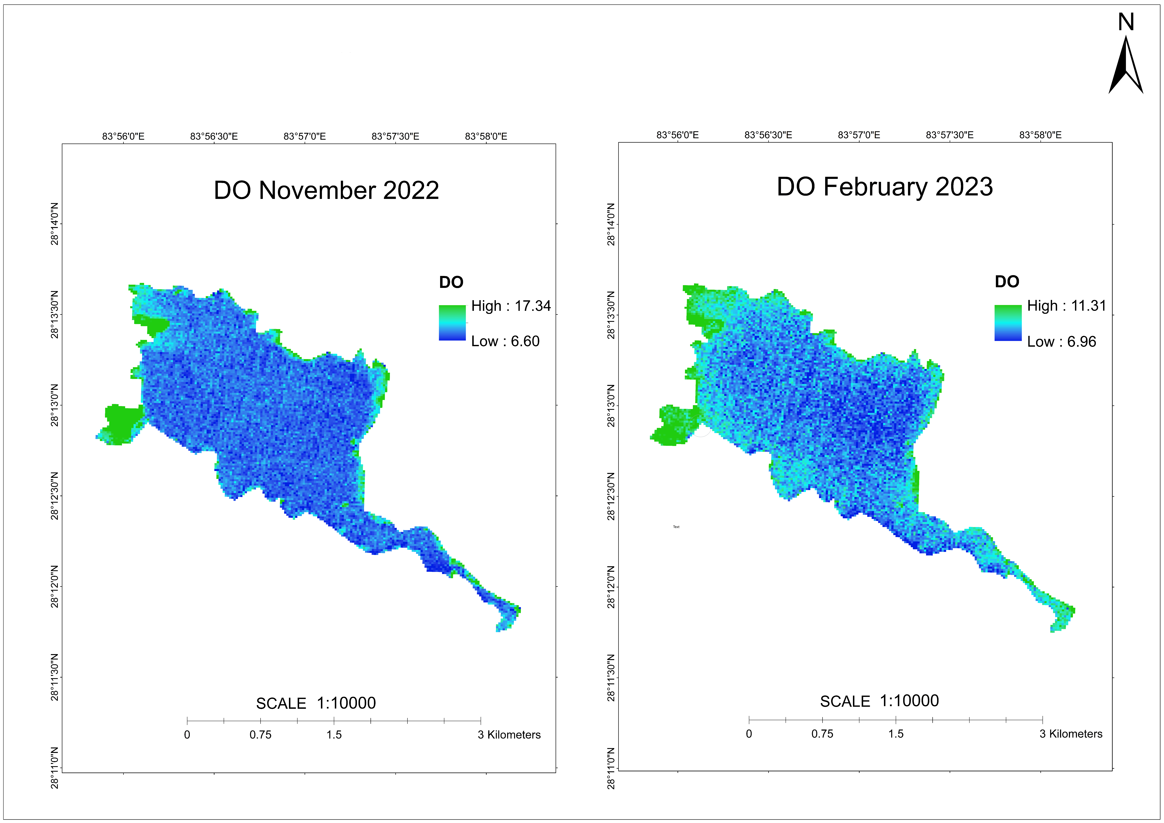

Figure 9: Output maps of DO of Phewa lake

From the map above, it is clear that the concentration of DO in November was higher than that in February in Phewa lake. It can also be noticed that the corners of the lake was higher in concentration of DO. The reason for higher concentration of DO in corners of lake may be due to the presence of aquatic plants, cooler water temperature and lower nutrient concentration. The DO concentration around Barahitemple was found to be 10.2 mg/litre in November 2022 and 9.6 mg/litre in February 2023 which shows the higher concentration in first visit.

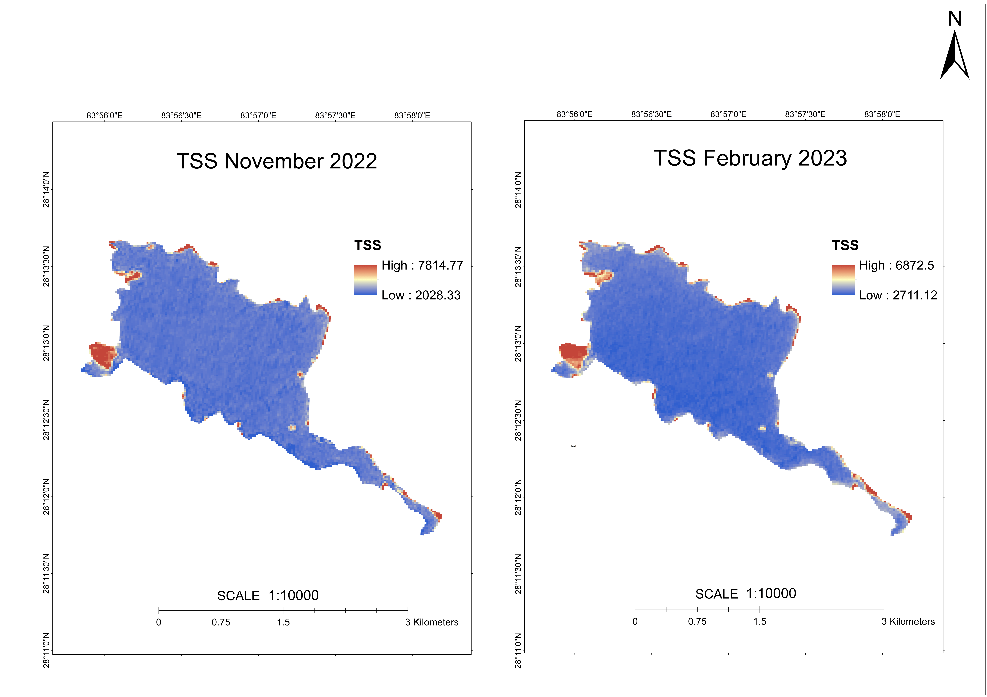

Figure 10: Output maps of TSS of Phewa lake

Observing the results from the map, it shows us that the amount of TSS in Phewa lake during the visit in November 2022 was higher than that in February 2023. The higher concentration of TSS around the corners of lake may be due to the rapid urbanization around the lake area. Different human activities around the lakes is also the main reason for high TSS. Not only this, inflow from streams and rivers flowing to the lake may also be major reason. The TSS concentration around Barahi temple was 3500 mg/litre in November 2022 while 3300 mg/litre in February 2023.

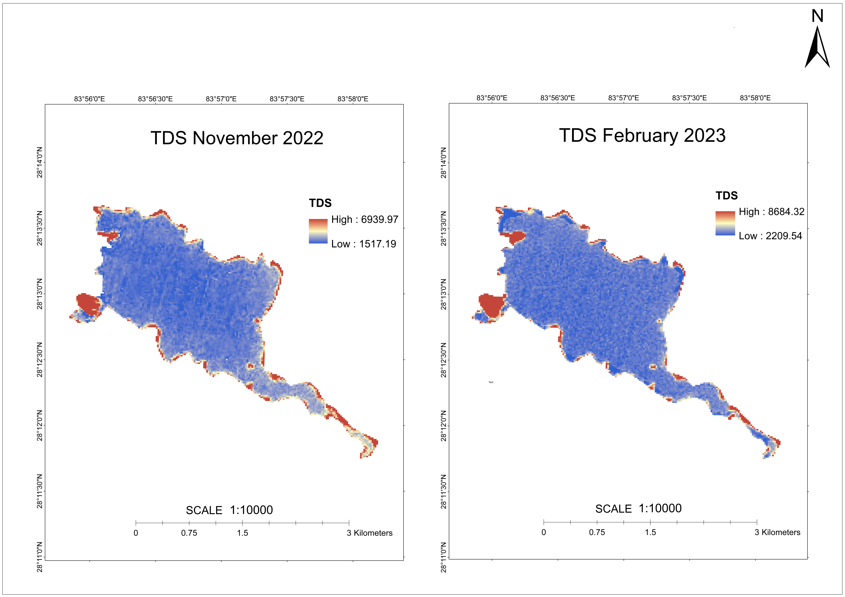

Figure 11: Output maps of TDS of Phewa lake

TDS in the Phewa lake was also observed to be higher around the corners. The concentration of TDS was found to be higher in the month of February than in November. The reason for high TDS around the corners of lake in February may be due to low water flow in lake, water temperature and also due to some kind of human activities. The concentration of TDS around Gaurighat park in the month of November was 2800 mg/litre and that in February was 3100 mg/litre.

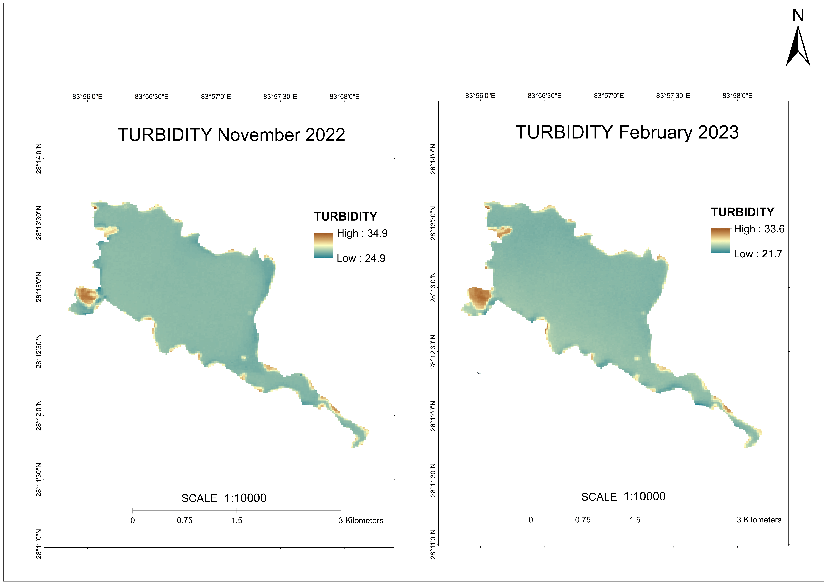

Figure 12: Output maps of Turbidity of Phewa lake

The concentration of turbidity in Phewa lake was found to be slightly higher in the month of November than in the month of February. Not much drastic changes were observed in the lake surrounding considering turbidity concentration. The reasons for water being slightly turbid in November may be due to rainfall, agricultural practices and human activities.

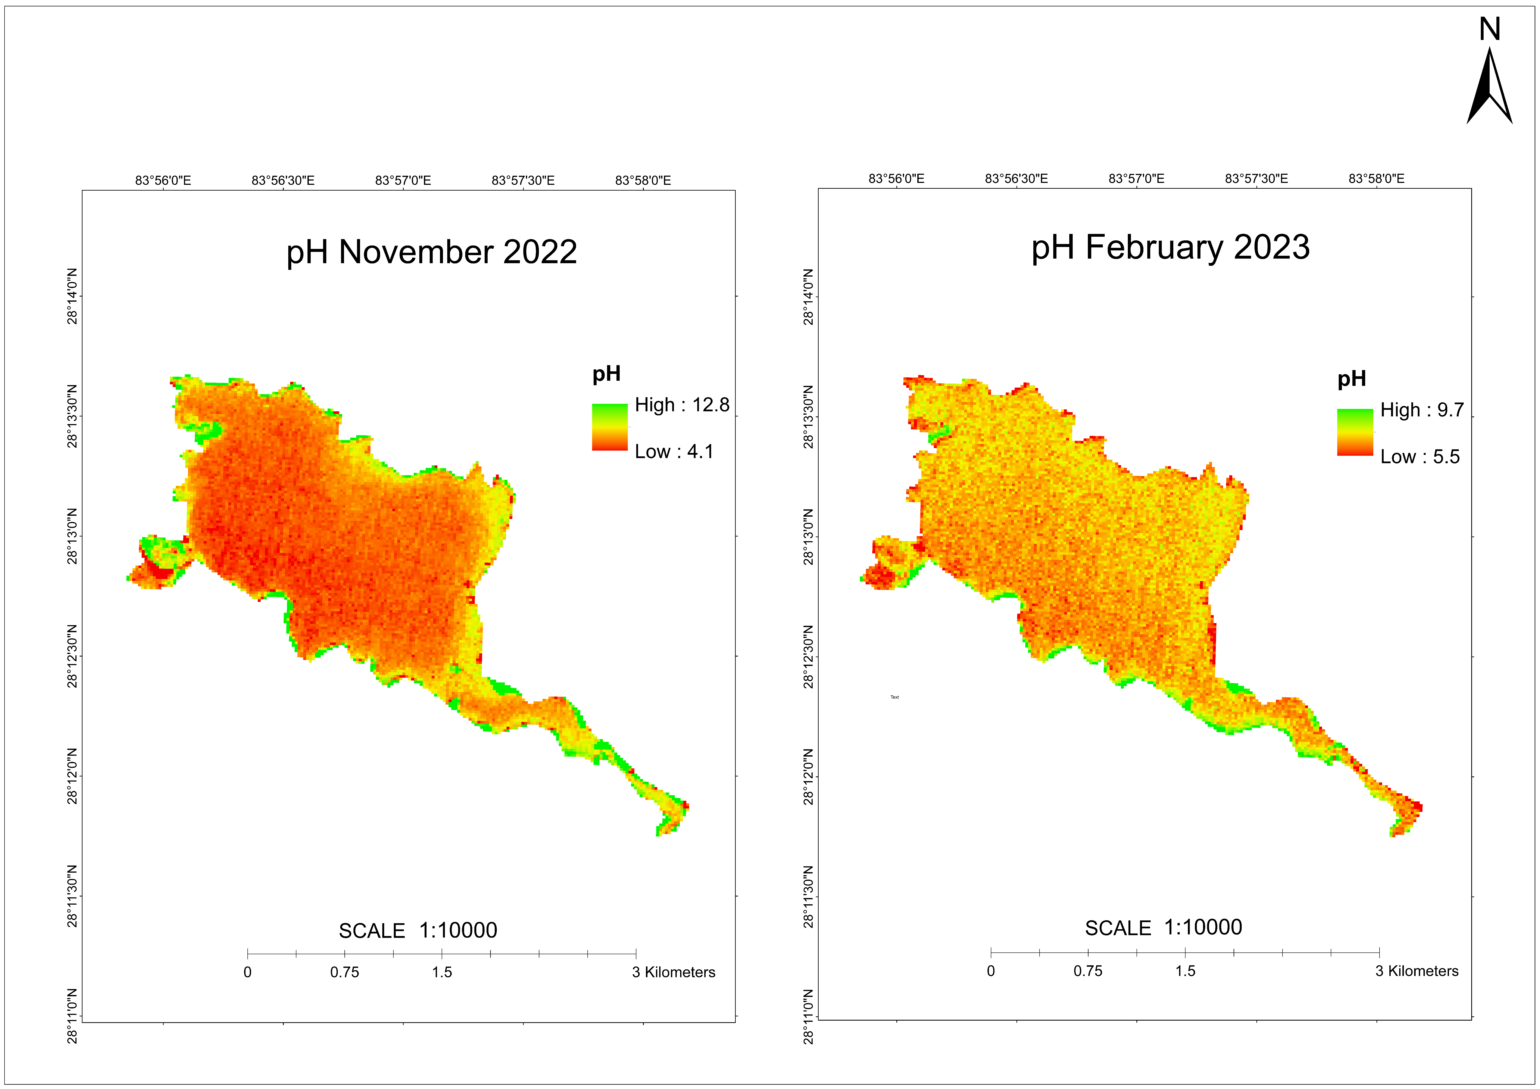

Figure 13: Output maps of pH of Phewa lake

The water in the lake was observed to be slightly acidic in the month of November observing the map above. Lower the value of water than 7, the more acidic the water gets. But the corners of the lake can be seen to have water with basic properties. The reason for slightly acidic level in the month of November may be due to weather patterns, seasonal changes, atmospheric deposition and human activities.

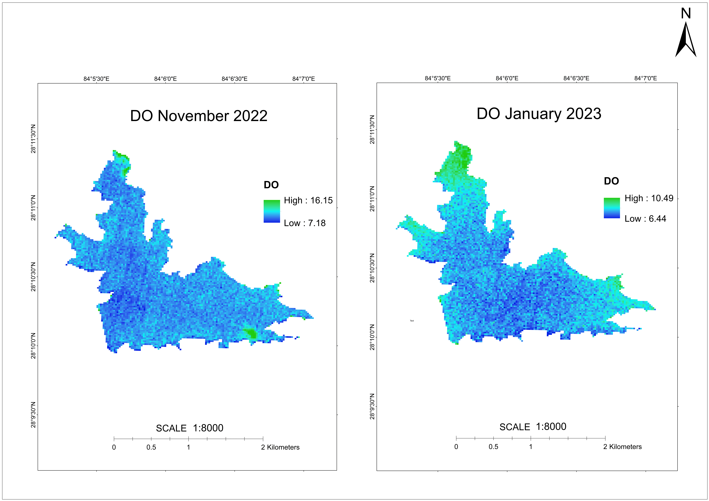

Figure 14: Output maps of DO of Begnas lake

It is evident from the map above that at Begnas Lake, the DO concentration in November was higher than that in February. Additionally, the higher DO concentration in the lake's corners was apparent. Due to the presence of aquatic plants, cooler water temperatures, and lower nutrient concentrations, the lake's corners may have higher concentrations of DO. The DO concentration was reported to be 9.6 mg/litre surrounding the Majhikuna in November 2022 and 7.6 mg/litre in Janaury indicating a greater concentration on the initial visit.

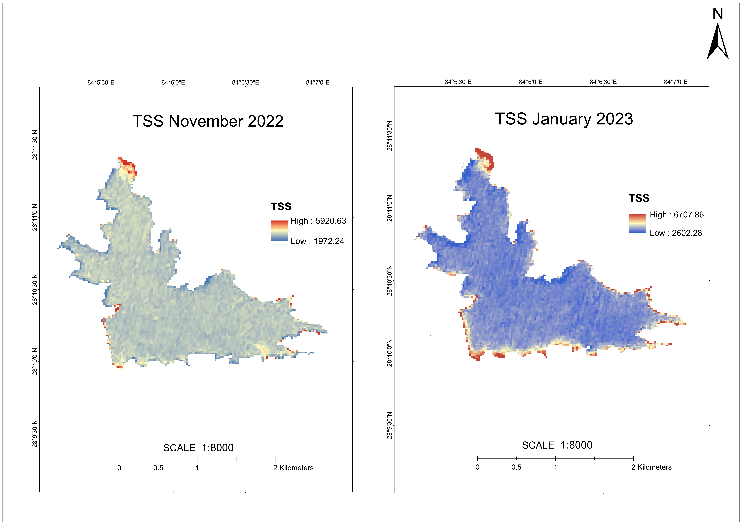

Figure 15: Output maps of TSS of Begnas lake

As we can see from the map's findings, the TSS concentration in Begnas Lake in November 2022 was lower than it was in February 2023. The growing development in the lake area may be the cause of the greater TSS concentration towards the lake's edges. High TSS is also primarily caused by various human activities in the area around the lakes. In addition, input from rivers and streams pouring into the lake may also play a significant role. In November 2022, there was 2600 TSS near Majhikuna, whereas there were 2800 in January 2023.

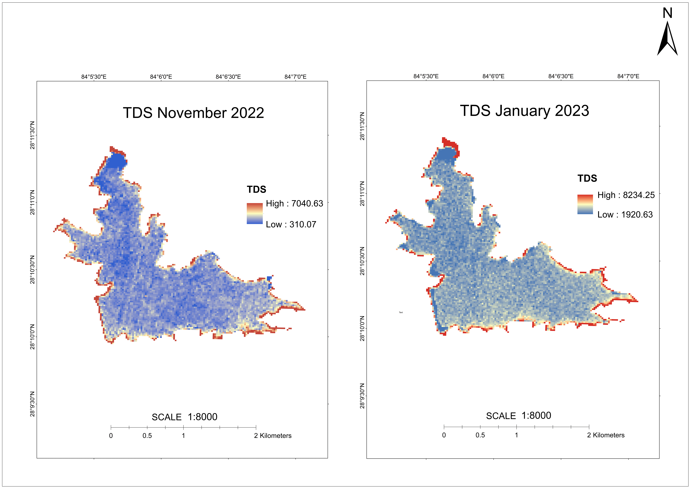

Figure 16: Output maps of TDS of Begnas lake

Additionally, higher TDS was noted in the corners of the Begnas Lake. It was discovered that the TDS concentration was higher in January than it was in November. The explanation for the high TDS in the lake's corners in January may be related to the lake's low water flow, the lake's warm water, as well as some types of human activity. TDS levels in the area of Temple gate ranged 2400 mg/litre in November and 3000 mg/litre in January.

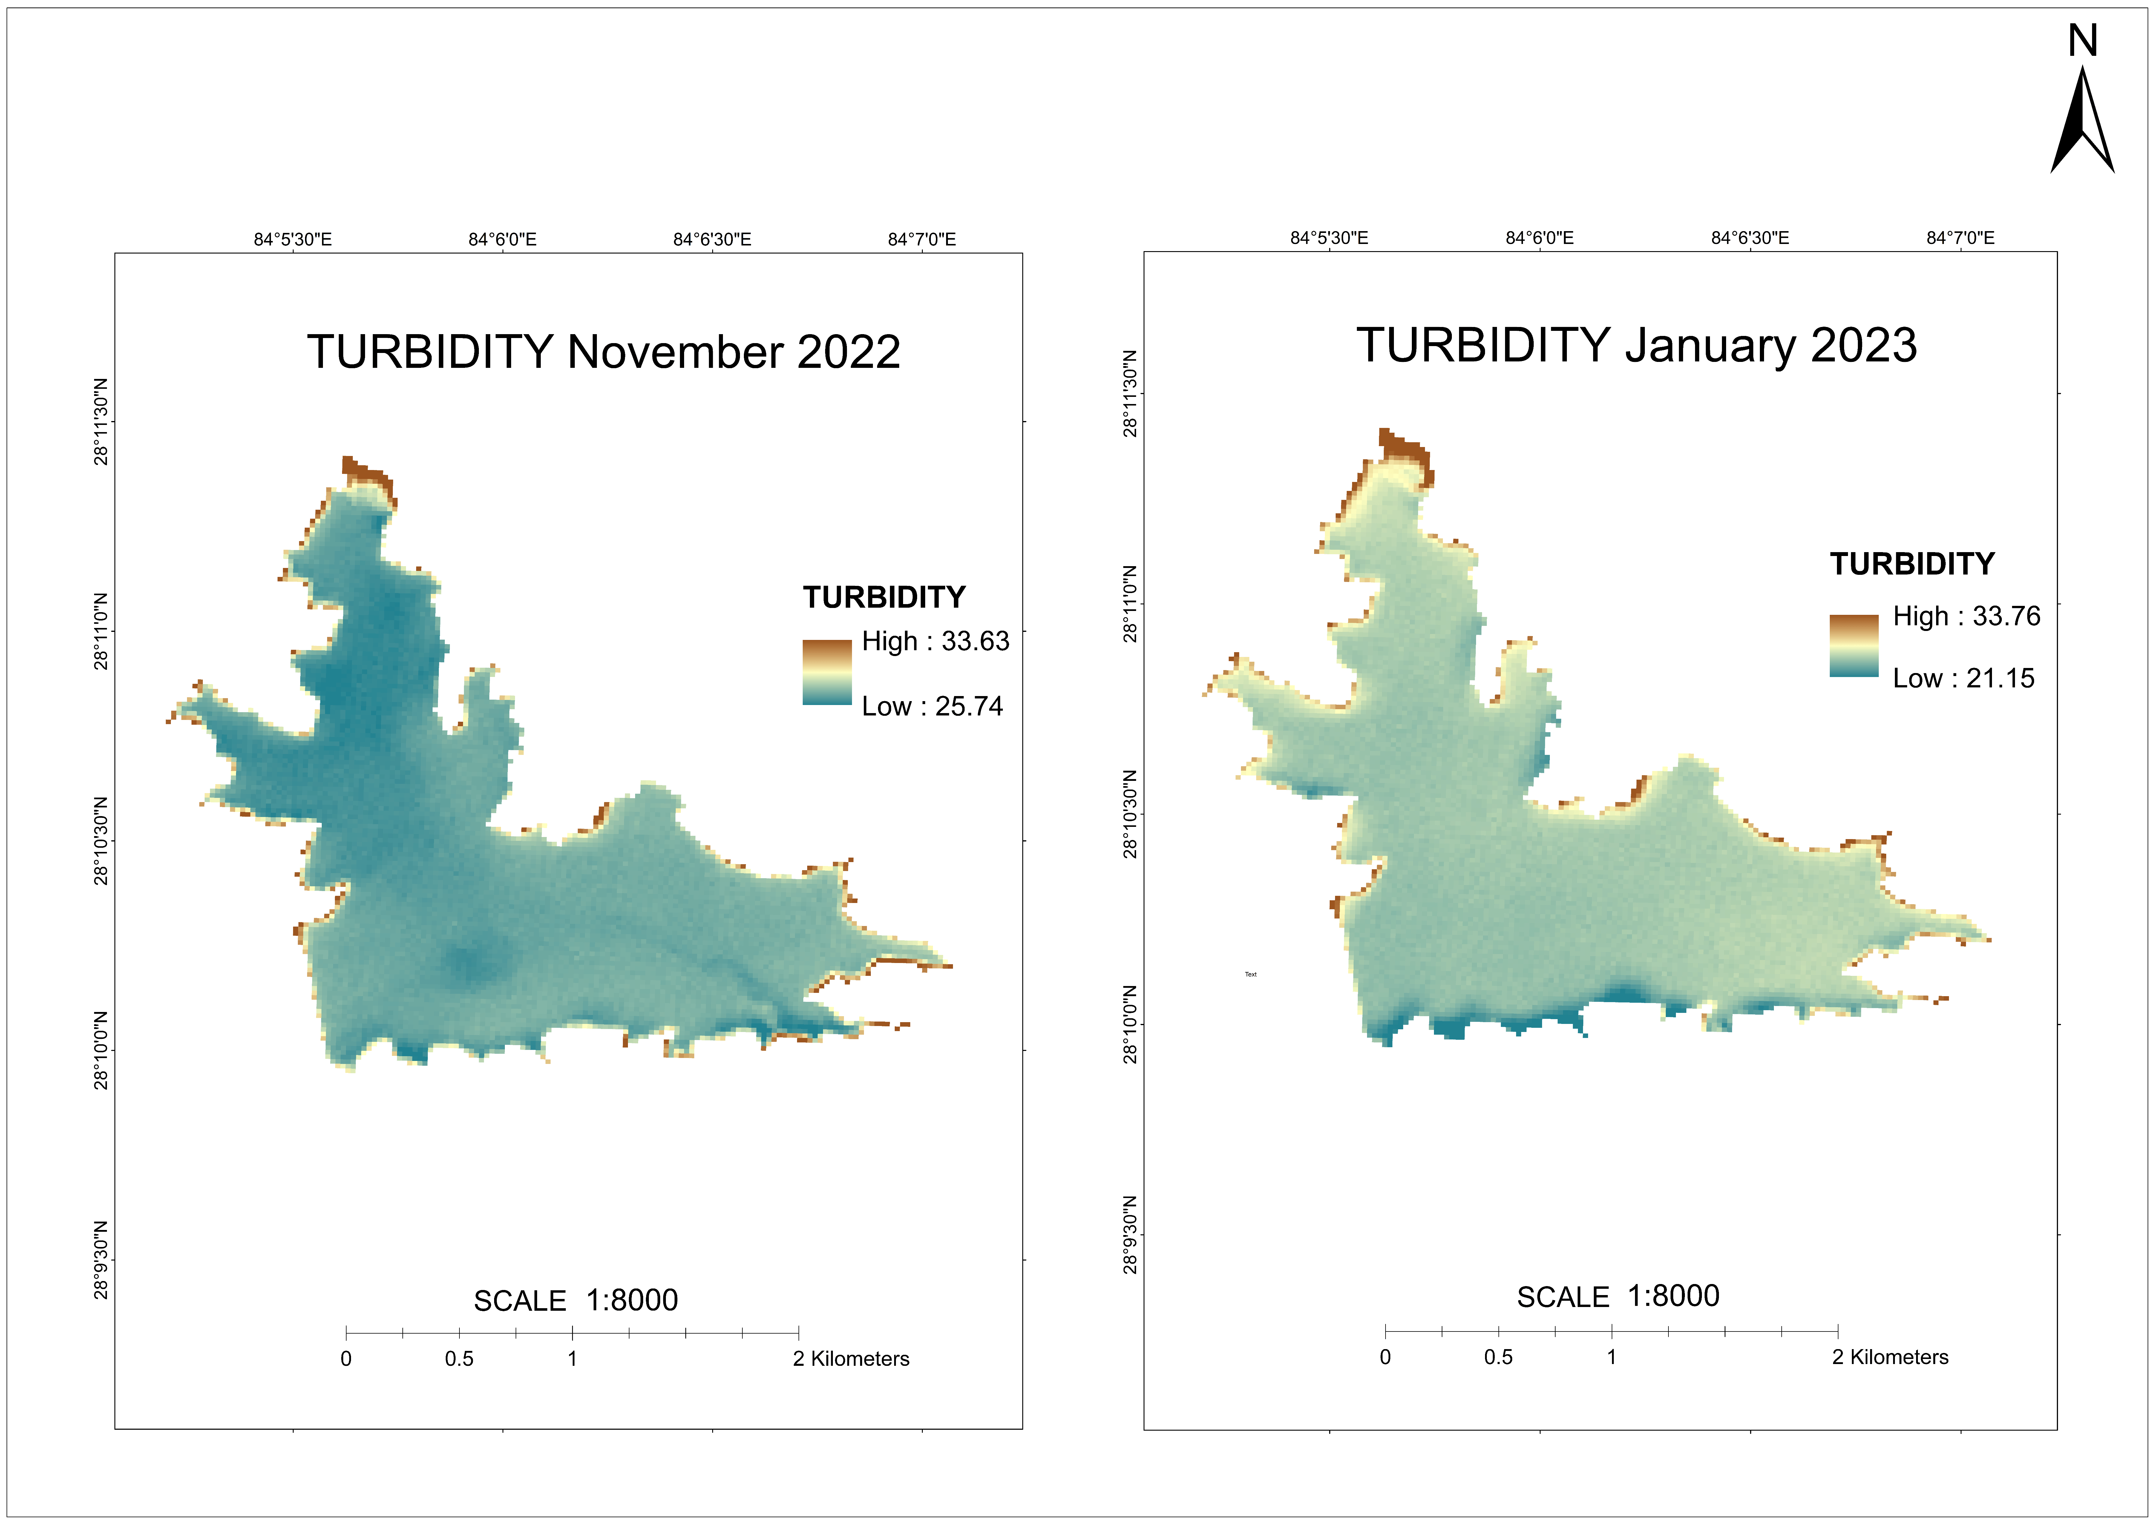

Figure 17: Output maps of Turbidity of Begnas lake

It was discovered that the month of November had a little greater turbidity concentration than the month of January had in Begnas Lake. When the adjacent lake's turbidity concentration was taken into account, not many significant changes were seen. November's water turbidity may be brought on by rainfall, agricultural practices, and human activity.

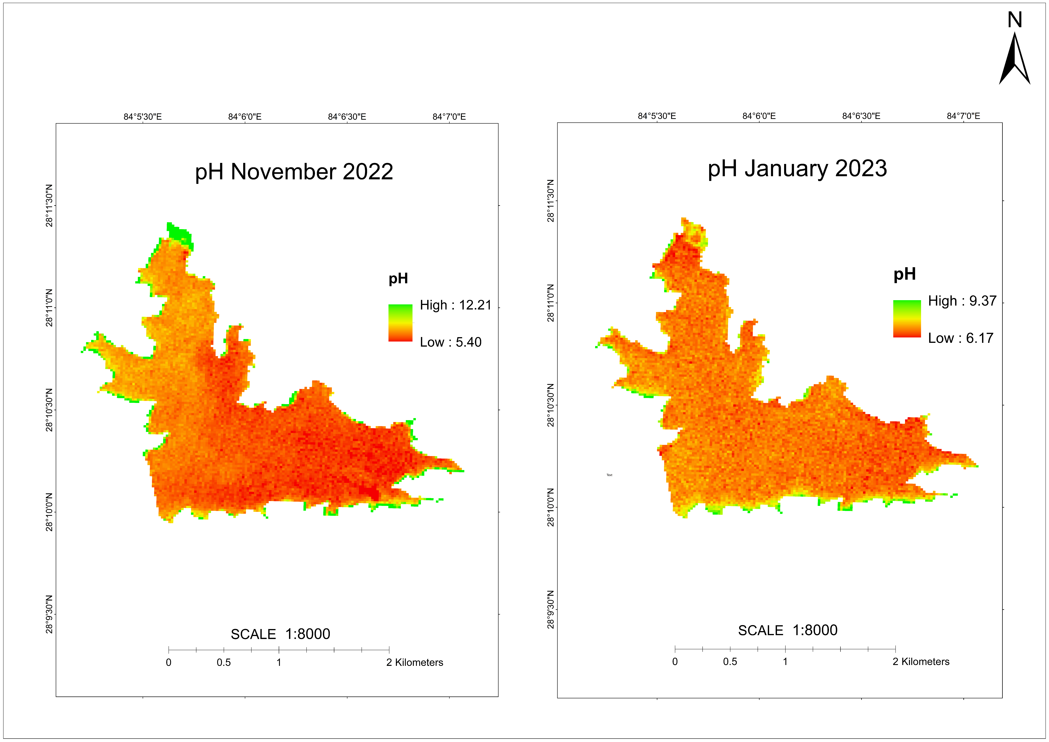

Figure 18: Output maps of pH for Begnas lake

On the basis of the map above, it was determined that the lake's water was somewhat acidic in November. The less the value of water gets to 7, the more acidic it becomes. The lake's corners, however, appear to have water with more basic characteristics. It's possible that weather cycles, seasonal shifts, atmospheric deposition, and human activities are to blame for November's mildly acidic level.

## 4.4Validation

### 4.4.1 Validation Results

Table 13: Validation results for Phewa lake (November 2022)

|  |  |  |  |  |  |  |  |  |
| --- | --- | --- | --- | --- | --- | --- | --- | --- |
| points | Area | Latitude | Longitude | Turbidity | TSS | TDS | pH | DO |
| 16 | Fishtail lodge | 28.20158 | 83.96366 | 29.36 | 2819 | 2500 | 7.5 | 9.02 |
| 17 | Forest area | 28.19908 | 83.9661 | 27.18 | 2458 | 2790 | 7.6 | 8.23 |
| 18 | Damside | 28.1968 | 83.9684 | 27.7 | 2483 | 2622 | 7.2 | 8.81 |
| 19 | Boating area | 28.19726 | 83.9695 | 29.69 | 3422 | 3450 | 7.7 | 10.19 |
| 20 | Phirke khola | 28.19918 | 83.96752 | 27.73 | 2489 | 2541 | 6.5 | 10.67 |
| 21 | Basundhara park | 28.20503 | 83.96105 | 27.62 | 2532 | 2342 | 6.8 | 8.77 |
| 22 | Gaurighat park | 28.20572 | 83.95681 | 28.46 | 2407 | 2629 | 7.7 | 8.44 |
| 23 | Center area | 28.20633 | 83.9556 | 26.9 | 2506 | 2292 | 7.2 | 8.51 |
| 24 | Boating area | 28.20802 | 83.95511 | 28.06 | 2855 | 3172 | 6.6 | 9.58 |

Table 14: Validation results for Phewa lake (February 2023)

|  |  |  |  |  |  |  |  |  |
| --- | --- | --- | --- | --- | --- | --- | --- | --- |
| points | Area | Latitude | Longitude | Turbidity | TSS | TDS | pH | DO |
| 16 | Center | 28.20345 | 83.957 | 24.05 | 3040.91 | 2759.75 | 7.26 | 7.82 |
| 17 | fishtail lodge | 28.203 | 83.96097 | 24.88 | 2894.56 | 2768.48 | 7.06 | 8.38 |
| 18 | Fishing area | 28.20173 | 83.96365 | 25.06 | 3158.23 | 2958.33 | 6.76 | 8.48 |
| 19 | Dam area | 28.19868 | 83.96698 | 23.92 | 3331.44 | 2705.32 | 7.19 | 8.07 |
| 20 | Phirke khola | 28.1972 | 83.96932 | 24.87 | 3174.86 | 3390.25 | 6.69 | 8.3 |
| 21 | Fishing area | 28.19797 | 83.96915 | 25.97 | 4056.68 | 3405.25 | 6.99 | 7.62 |
| 22 | Basundhara park | 28.20205 | 83.96322 | 24.77 | 2976.89 | 3154.36 | 6.89 | 8.04 |
| 23 | Boating area | 28.20305 | 83.9626 | 24.82 | 2939.02 | 3050.76 | 6.68 | 8.63 |
| 24 | Gaurighat park | 28.20518 | 83.96098 | 25.22 | 3177.59 | 3089.12 | 6.66 | 8.77 |
| 25 | Center | 28.20578 | 83.95633 | 24.99 | 2917.67 | 2971.64 | 7.02 | 7.75 |
| 26 | Boating area | 28.20787 | 83.95501 | 24.73 | 2964.34 | 3174.7 | 7.01 | 7.83 |

Table 15: Validation results for Begnas lake (November 2022)

|  |  |  |  |  |  |  |  |  |
| --- | --- | --- | --- | --- | --- | --- | --- | --- |
| points | Area | Latitude | Longitude | Turbidity | TSS | TDS | pH | DO |
| 16 | Hotel area | 28.16734 | 84.11048 | 26.67 | 2663.58 | 2757.54 | 6.92 | 9.69 |
| 17 | Center area | 28.17031 | 84.1148 | 28.56 | 2490.08 | 3060.49 | 6.8 | 9.37 |
| 18 | Majhikuna | 28.16829 | 84.11301 | 28.46 | 2552.01 | 3014.76 | 6.64 | 9.22 |
| 19 | Agriculture area | 28.17357 | 84.11129 | 28.28 | 2433.02 | 2848.48 | 6.52 | 9.77 |
| 20 | Libdi khola junction | 28.17702 | 84.106 | 27.43 | 2599.03 | 2266.02 | 6.42 | 9.58 |
| 21 | Hotel fishing area | 28.17525 | 84.10522 | 27.38 | 3085.4 | 2371.76 | 6.42 | 9.54 |
| 22 | Forest area | 28.17506 | 84.10301 | 27.73 | 2467.13 | 2302.01 | 6.15 | 9.34 |
| 23 | Center area | 28.1736 | 84.1005 | 27.14 | 2533.7 | 2384.25 | 6.21 | 9.53 |
| 24 | Center area | 28.17101 | 84.09761 | 26.95 | 2514.76 | 2333.29 | 6.4 | 9.29 |

Table 16: Validation results for Begnas lake (January 2023)

|  |  |  |  |  |  |  |  |  |
| --- | --- | --- | --- | --- | --- | --- | --- | --- |
| points | Area | Latitude | Longitude | Turbidity | TSS | TDS | pH | DO |
| 16 | Fishing area | 28.18276 | 84.09764 | 24.37 | 3115.33 | 2653.51 | 7.11 | 8.51 |
| 17 | Agriculture area | 28.18687 | 84.094957 | 24.83 | 3051.96 | 2632.44 | 6.72 | 9.38 |
| 18 | Syankhudi jharana | 28.18819 | 84.09389 | 25.35 | 3081.31 | 2218.89 | 6.76 | 9.27 |
| 19 | Forest area | 28.18458 | 84.09364 | 24.79 | 2906.04 | 2801.27 | 6.91 | 8.78 |
| 20 | Center | 28.181 | 84.09446 | 24.53 | 2939.69 | 2778.23 | 6.87 | 8.75 |
| 21 | Residental area | 28.17785 | 84.09231 | 24.45 | 2910.59 | 2826.98 | 6.96 | 8.02 |
| 22 | Hotel area | 28.17497 | 84.09394 | 24.46 | 2933.27 | 2807.44 | 6.86 | 8.38 |
| 23 | Hotel fishing area | 28.17299 | 84.09405 | 24.57 | 2852.48 | 3094.65 | 6.96 | 8.08 |
| 24 | Dam side | 28.17032 | 84.09309 | 24.38 | 2997.62 | 2739.71 | 6.93 | 7.85 |
| 25 | Boating area | 28.16636 | 84.09339 | 23.47 | 3289.49 | 2664.63 | 7.05 | 8.22 |

### 4.4.2 Validation Graphs

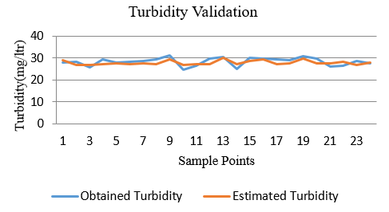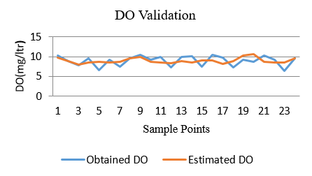

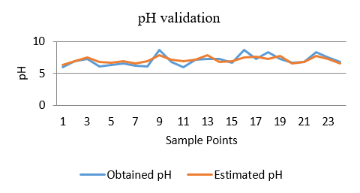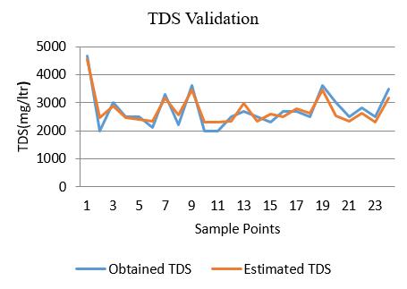

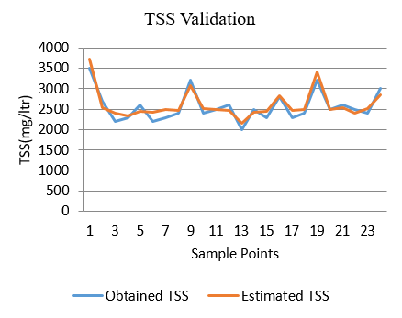

Figure 19: Validation graphs for Phewa lake (November 2022)

Figure 20: Validation Graphs for Phewa lake (February 2023)

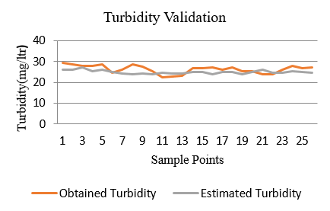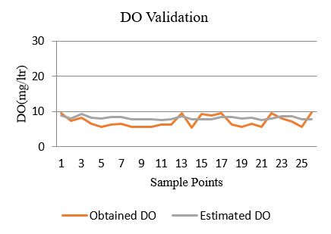

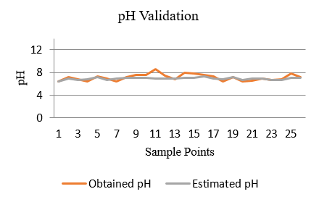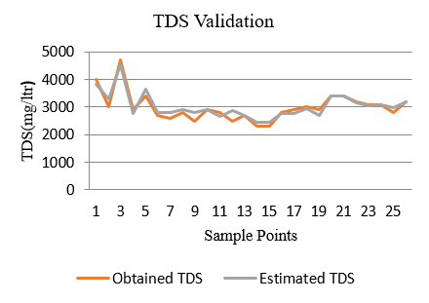

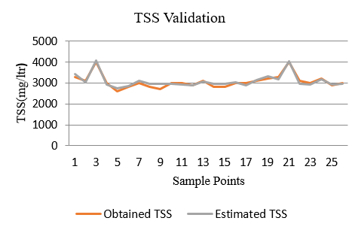

Figure 21: Validation Graphs for Begnas lake (November 2022)

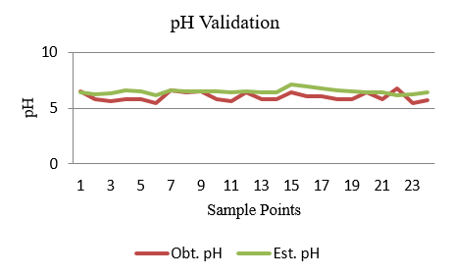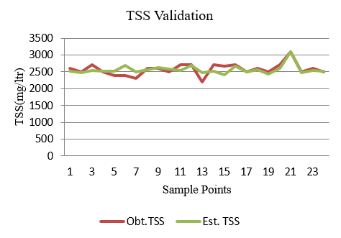

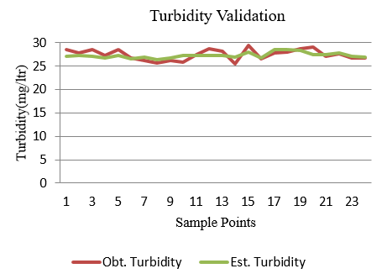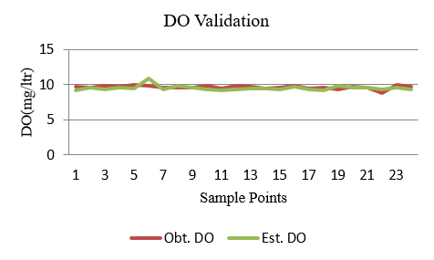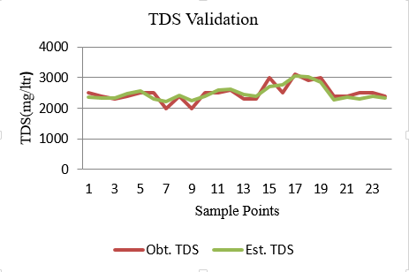

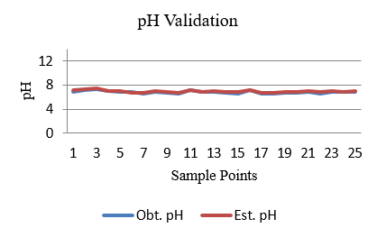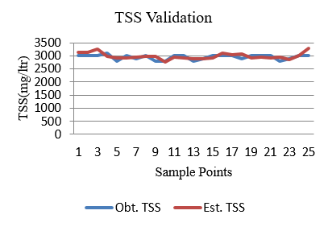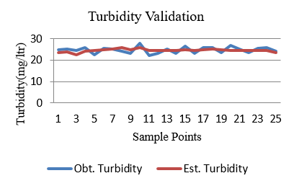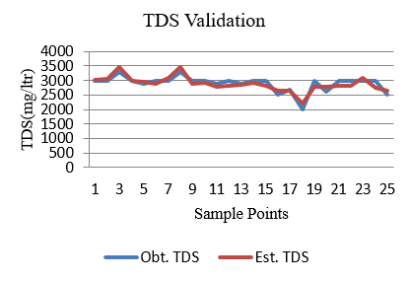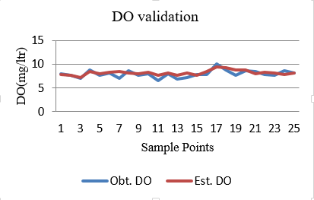

Figure 22: Validation Graphs for Begnas lake (January 2023)

## 4.5 Problems Encountered and Remedies

### 4.5.1 Problems Encountered

* Getting the cloud free data from Copernicus Open Access Hub was difficult due to unpredictable weather conditions.
* A pixel has resolution of 20m which covers 20 metres of ground length and width. So, it was difficult to model the parameters accurately.
* Due to lack of availability of proper instruments and chemicals in lab, the results obtained were not accurate.

### 4.5.2 Remedies

* The results of the project would have been enhanced if higher resolution images were available.
* Availability of well-equipped chemical lab.

## 4.6 Discussion

The optical parameters: turbidity, total suspended solids, total dissolved solids and non-optical parameters: dissolved oxygen were measured through chemical tests and later were determined by the suitable obtained model. The correlation techniques were used to find the relation between optical and non-optical parameters and regression techniques was used to find the appropriate relation between band image and surface water quality parameters. An effective model to determine water quality was developed by deriving relation between parameters and band image. By combining remote sensing data with GIS, it enabled us to develop models that predict future water quality trends based on past observation and current condition. Those different mathematical models for different water quality parameters were executed on GIS and various thematic maps were prepared to analyse the data and determine the relationship and pattern between the input variable and output

The study's findings offer a strong tool for decision-making processes in surface water quality measurement because they enable the efficient and consistent use of both spatial and non-spatial data.

# Chapter 5 CONCLUSION AND RECOMMENDATION

## 5.1 Conclusion

Water quality indicators including physical, chemical, and biological properties are traditionally determined by collecting samples from the field and then analysing the samples in the laboratory. Traditional analysis of lakes could only provide the pollution level at discrete position. Remote sensing and GIS techniques in conjunction with traditional in-situ sampling are found to be the most effective, cheaper and more reliable tools for monitoring water quality parameters in waterbodies. So, the proposed remote sensing method can be a very useful tool for providing the spatially continuous and descriptive information of the pollution parameters. WQ measurements at sample points were correlated with spectral reflectance values derived from satellite imagery via regression analysis.

Spectral information from Sentinel-2A satellite data are used to estimate the concentration of parameters like turbidity, pH, DO, TDS and TSS.

For the estimation of different parameters, different band combinations were used.

* Turbidity: Band 3, Band 5, Band 11
* pH: Band 3, Band 4, Band 8A
* DO: Band 2, Band 4, Band 12
* TDS: Band 4, Band 5, Band 11
* TSS: Band 5, Band 11, Band 12

Hence, the obtained models for different parameters can be used to estimate the water quality parameters of the different lakes within a certain limit of accuracy.

The concentration of the parameters varied in every sample points of the map. The reason for the higher value of DO could be because of presence of aquatic plants in water. Water in lake becomes acidic mainly due to human activities whereas, mineral deposit increases the alkalinity of the water (Marketing, 2022). The higher turbidity may be because of high and direct influence of human activities there (Biwas Babu Sadadev, 2020). Material that causes water to be turbid include clay, silt, very tiny inorganic and organic matter, algae, dissolved coloured organic compounds, and plankton and other microscopic organisms (WSS, 1994). High TSS in a water body can often mean higher concentrations of bacteria, nutrients, pesticides, and metals in the water (Group, 1998) . The amount of TDS is found to be higher in lakes due to natural environmental features such as mineral springs, carbonate deposits, salt deposits, and sea water intrusion (WQA, 2015).

## 5.2 Recommendation

From the project performed for the analysis of water quality using remote sensing methods, we recommend the following;

* Multispectral imageries such as Sentinel-2A can be used for large water bodies. So, hyperspectral airborne sensors have greater potential and need to be used to measure and monitor smaller water bodies.
* It is highly recommended that researchers, who work in the field of remote sensing to communicate more with water resource management agencies on using appropriate available tools to address important analysis requirements.
* These kinds of studies provide valuable information to the local administrators, to monitor the lakes and other water bodies and to take necessary actions when they are polluted.

# References

Aman K.C., A. C. (2019). Surface Water Quality Assessment using Remote Sensing, GIS and Artificial Intelligence. *Technical Journal*, 113-122.

Biwas Babu Sadadev, K. B. (2020). Comparative Study of Water Quality Index of Phewa,Rupa and Begnas Lakes.

Blake A. Schaeffer, K. G. (2013). Barriers to adopting satellite remote sensing for water quality analysis. *International Journal of Remote Sensing*, 7534-7544.

Cochran, W. G. (1991). *Sampling Techniques* (3rd ed.).

Dazhao Liu, C. C. (2010). Remote sensing of chlorophyll-a concentrations of the Pearl River Estuary from MODIS land bands. *International Journal of Remote Sensing*, 4625-4633.

Din, E. H. (2018). Surface water quality assessment using a remote sensing, GIS, and mathematical modelling framework. *Scholar Research Repository*.

EPA. (1986). *Quality Criteria for Water.* Retrieved 2023, from https://en.wikipedia.org/wiki/Turbidity

Erhan Alparslan, U. A. (2009). Water Quality Determination of Kucukcekmece Lake,Turkey by using Multispectral Satellite Data. *The Scientific World Journal*.

ESA. (1975). *European Space Agency*. Retrieved 2023, from https://www.esa.int/

Gareth James, D. W. (2021). *An Introduction to Statistical Learning* (2nd ed.).

GISGeography. (2022). *GISGeography*. Retrieved 2023, from https://gisgeography.com/sentinel-2-bands-combinations/

Glibert, P. M. (2016). Delineating non-optical measurements in aquatic systems. *Journal of Marine Science and Engineering*.

Group, T. F. (1998). *Stream Corridor Restoration.*

Haibo Yang, J. K. (2022). A Review of Remote Sensing for Water Quality Retrieval: Progress and Challenges. *Remote Sensing*.

Howard R. Gordon, O. B. (1975). Computed Relationships Between the Inherent and Apparent Optical Properties of a Flat Homogeneous Ocean. *Applied Optics*, 417-427.

Isabelle Guyon, A. E. (2003). An Introduction to Variable and Feature Selection. *Journal of Machine Learning Research*(1157-1182).

Joseph M. Moran, M. D. (1986). *Introduction to environmental science* (2nd ed.). Retrieved 2023, from https://en.wikipedia.org/wiki/Total_suspended_solids

Jyotirmaya Ijaradar, S. C. (2018). Real-Time Water Quality Monitoring System. *International Research Journal of Engineering and Technology*.

K. Kallio, T. K. (2001). Retrieval of water quality from airborne imaging spectrometry of various lake types in different seasons. *Science of the Total Environment*, 59-77.

Kallio, K. (2000). Remote Sensing as a tool for Monitoring Lake Water Quality. In P. Heinonen, *Hydrological and Limnological Aspects of Lake Monitoring* (pp. 237-245).

LLC., E. (2022). *The Berkey* . Retrieved 2023, from https://theberkey.com/blogs

Marketing, E. (2022). *Eldorado Natural Spring Water*. Retrieved 2023, from https://www.eldoradosprings.com/

Michael H. Kutner, C. J. (2005). *Applied Linear Statistical Models* (5th ed.). McGraw Hill.

Mishra, A. K. (2011). Physico-chemical and optical properties of river water. . *Journal of Environmental Biology*, 299-304.

Mohammed Haji Gholizadeh, A. M. (2016). A Comprehensive Review on Water Quality Parameters Estimation using Remote Sensing Technique. *Sensors*.

Ramesh R. Pant, K. B. (2019). Water Quality Assessment of Begnas and Rupa Lakes, Lesser Himalaya Pokhara, Nepal. *Journal of the Institute of Engineering*, 113-122.

Vaishnavi V. Daigavance, D. M. (2017). Water Quality Monitoring System based on IOT. *Advances in Wireless and Mobile Communications*, 1107-1116.

WQA, W. Q. (2015). *Know your H2O*. Retrieved 2023, from https://www.knowyourh2o.com/

WSS, W. S. (1994). *USGS*. Retrieved 2023, from https://www.usgs.gov/

Zhang, Y. P. (2003). Water quality retrievals from combined Landsat TM data and ERS-2 SAR data in the Gulf of Finland. *IEEE Transactions on Geo-Science and Remote Sensing*, 622-629.

# Annexes

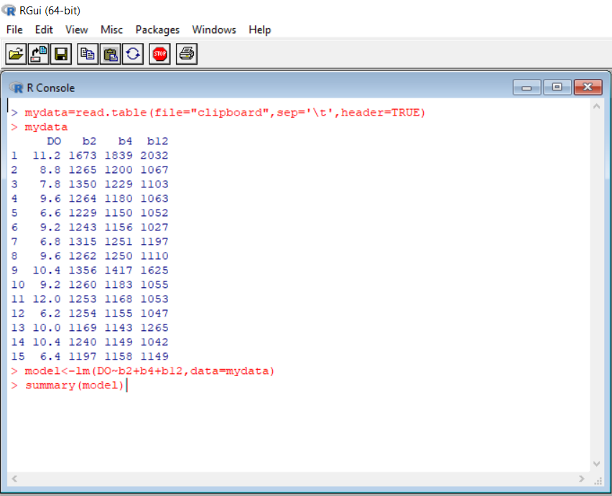

*Fig 1. Program to develop model in R-studio*

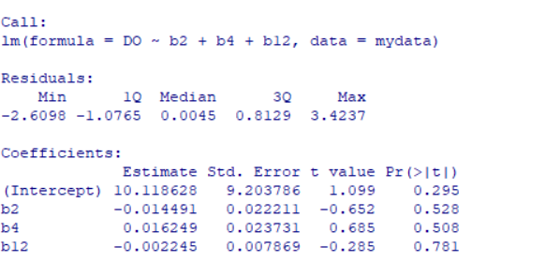

*Fig 2. Output for developing model in R-studio*

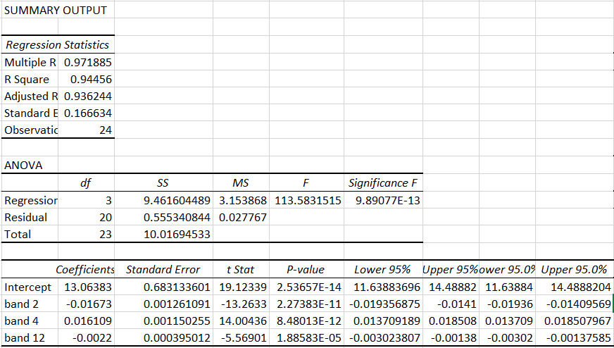

*Fig 3. Coefficient of determination (R²) from MS-Excel*

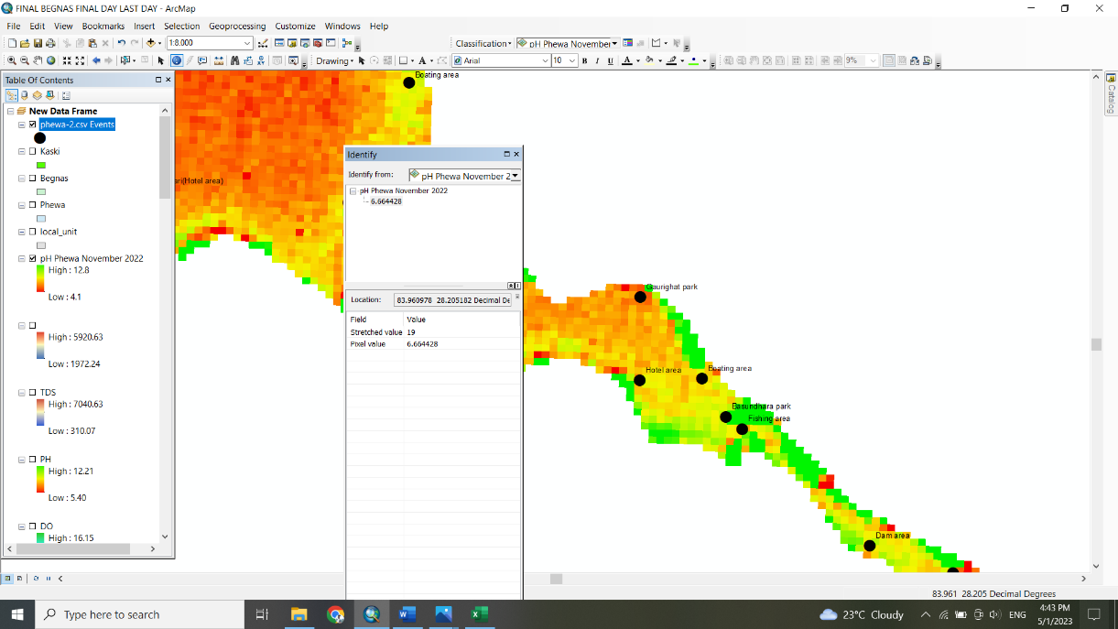

*Fig 4. Gaurighat Park pixel value in February 2023*

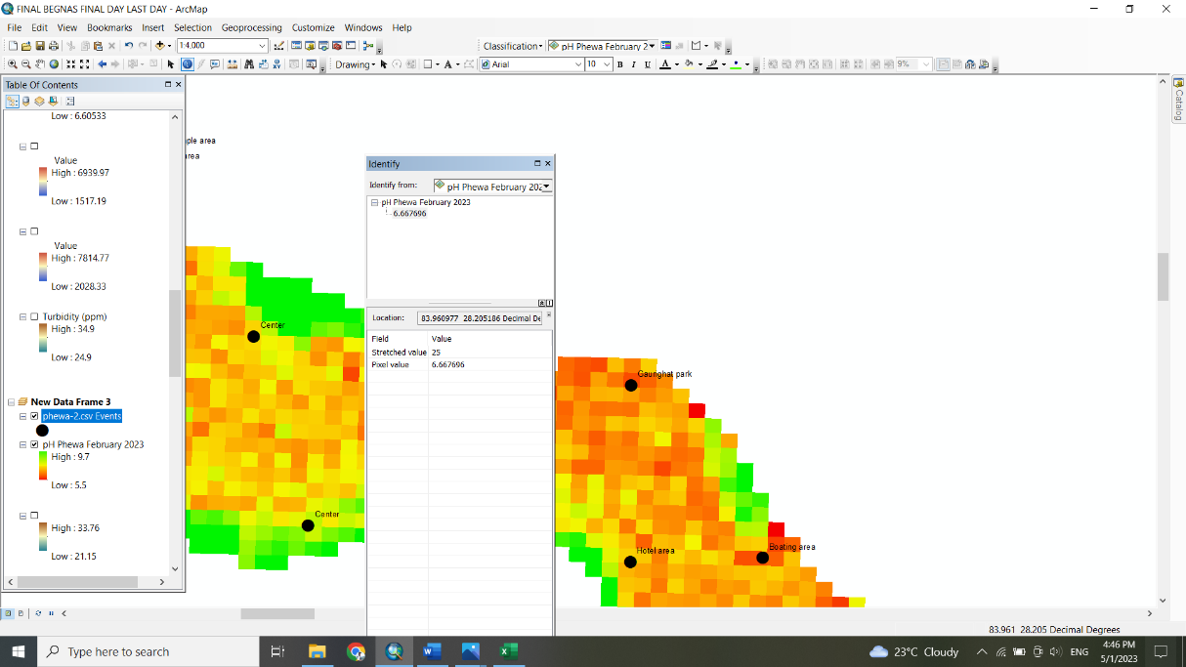

*Fig 5. Gaurighat Park pixel value in November 2022*

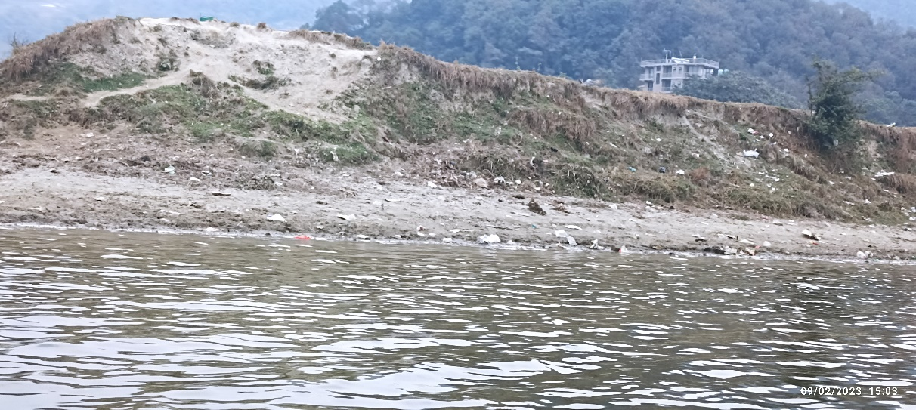

*Fig 6. TSS in Phewa lake*

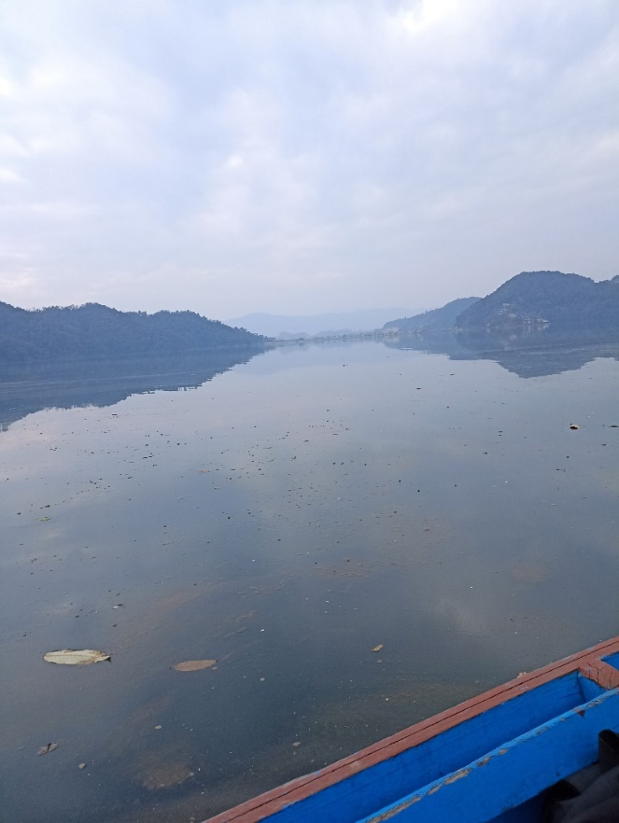

*Fig 7. Turbidity on surface of Phewa lake*

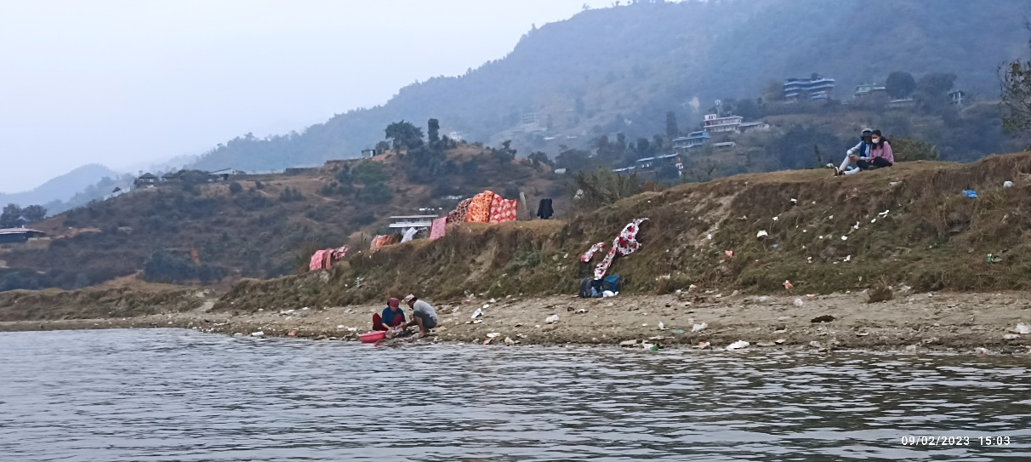

*Fig 8. People washing clothes in Phewa lake*

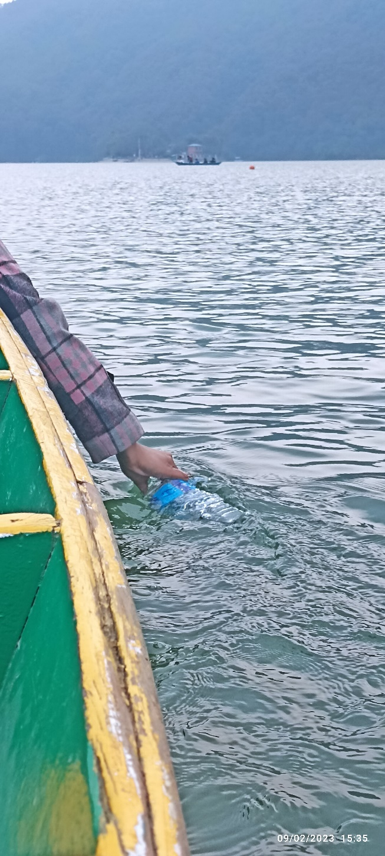

*Fig 9. Collection of sample in Phewa lake*

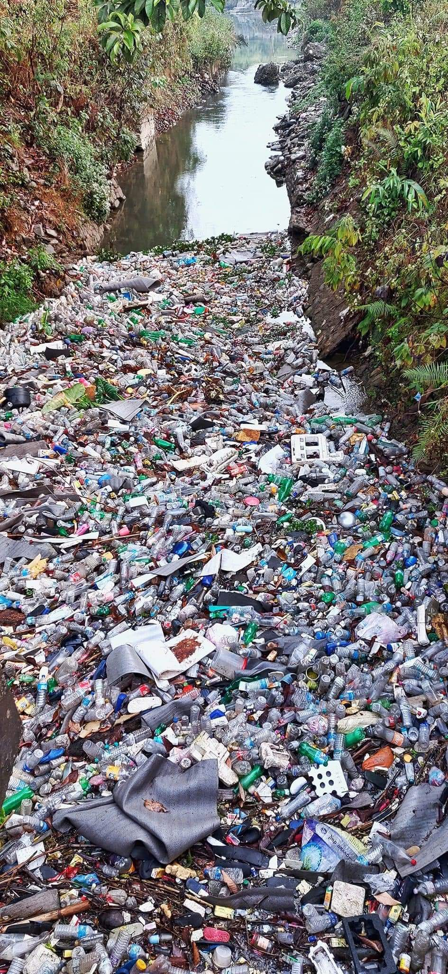

*Fig 10. Pollution on Phewa lake*

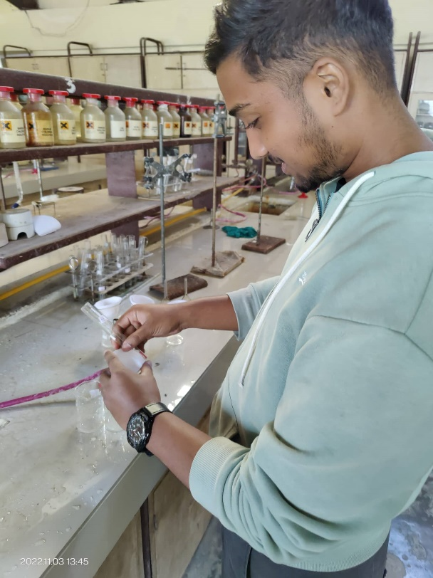

*Fig 11. Laboratory work*

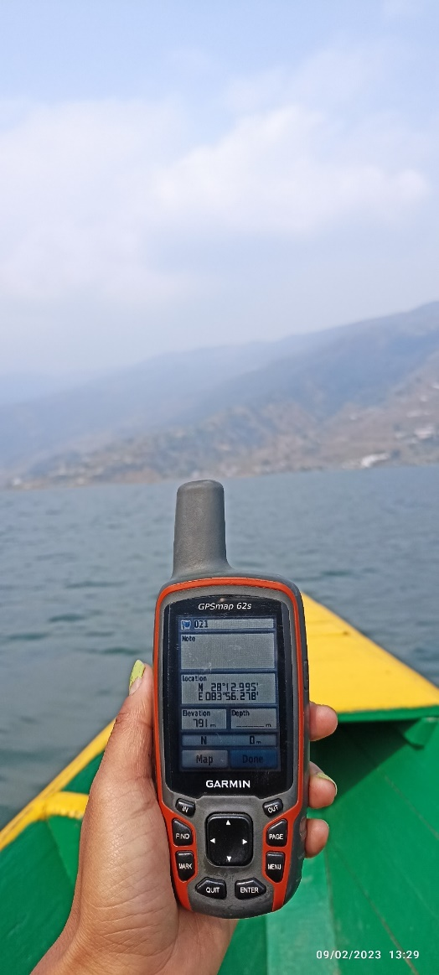

*Fig 12. GPS to record locations*